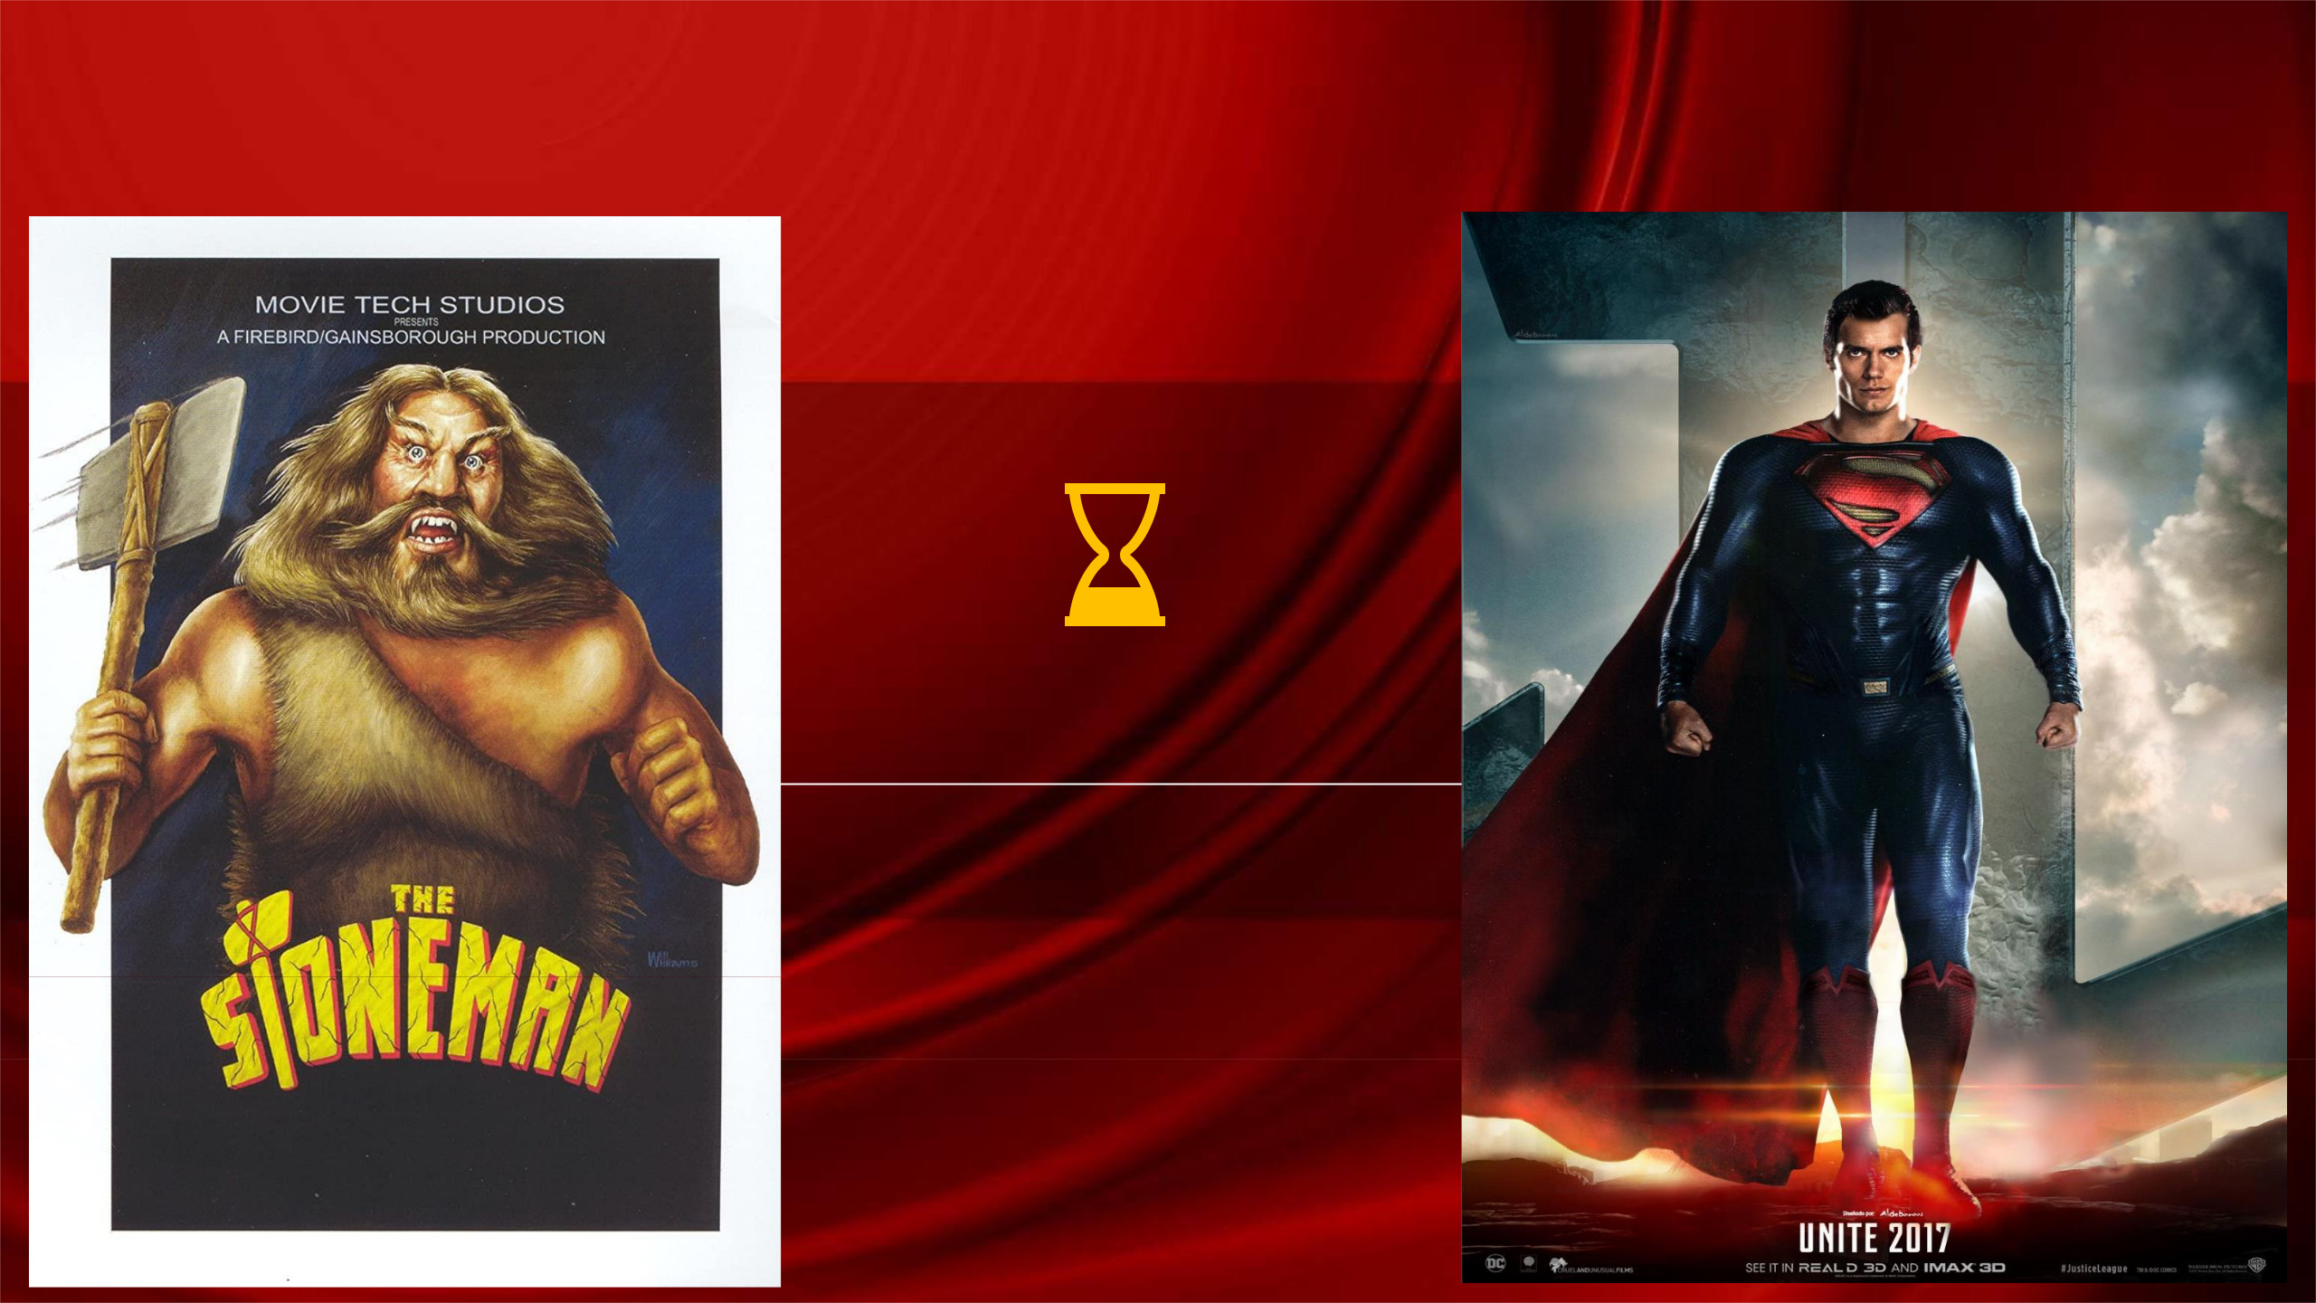Sitecore 10 Certification Crash-Course

StonemantoSuperman

**60 minutes**

- NAVAN

Table of Contents

Master vs Web DB

Data Templates

Template Inheritance

Insert options

Standard Values

Field Editor Button Use

Presentation Details

* Layout
* Controls
* Placeholder Settings Dynamic Placeholder

Static vs Dynamic Component Binding Sitecore MVC Concepts

* Layout
* View Rendering

Sitecore Rendering properties

Visual Studio Publish vs Sitecore Publish

Versioned Layouts

Site Definition Patch Config

Sharing Content between Sites

Config File Load Order

Layers.config

Sitecore Support Package

Sitecore Security Domains

Sitecore.IdentityServer.Host.xml

User Manager

Role Manager

Security - Users/Groups

Workflow

Elements of Workflow

Workbox

Sitecore [ASP.NET](http://asp.net/) Core Rendering Host

Sitecore Headless Service

Sitecore [ASP.NET](http://asp.net/) Rendering SDK

Startup.cs functionality

Service Registration in Startup.cs

Sitecore CLI Plugin Setup

Sitecore CLI - sitecore.json

Sitecore CLI - module.json

Sitecore CLI vs Sitecore for Visual Studio

Sitecore Docker Lifecycle

.env file

General Tips

Sitecore Exam Competencies

* **50 questions, 2 hrs**
* **Online-proctored; need a separate camera, laptop camera won’t suffice**
* **Mark for review option**
* **Check for Sitecore Partner coupon with employer for exam discount**

[**https://navansitecorenotes.blogspot.com/2022/02/sitecore-10-exam-competencies.html**](https://navansitecorenotes.blogspot.com/2022/02/sitecore-10-exam-competencies.html)

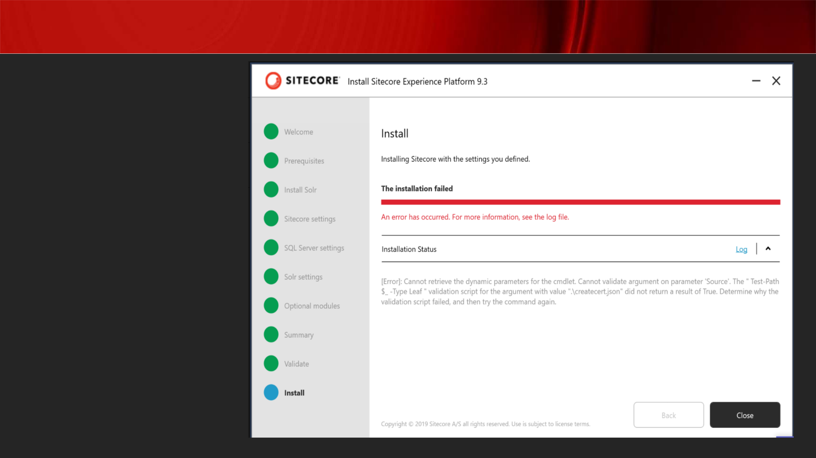SIA Installation Errors

**Missing Certificates Folder:**

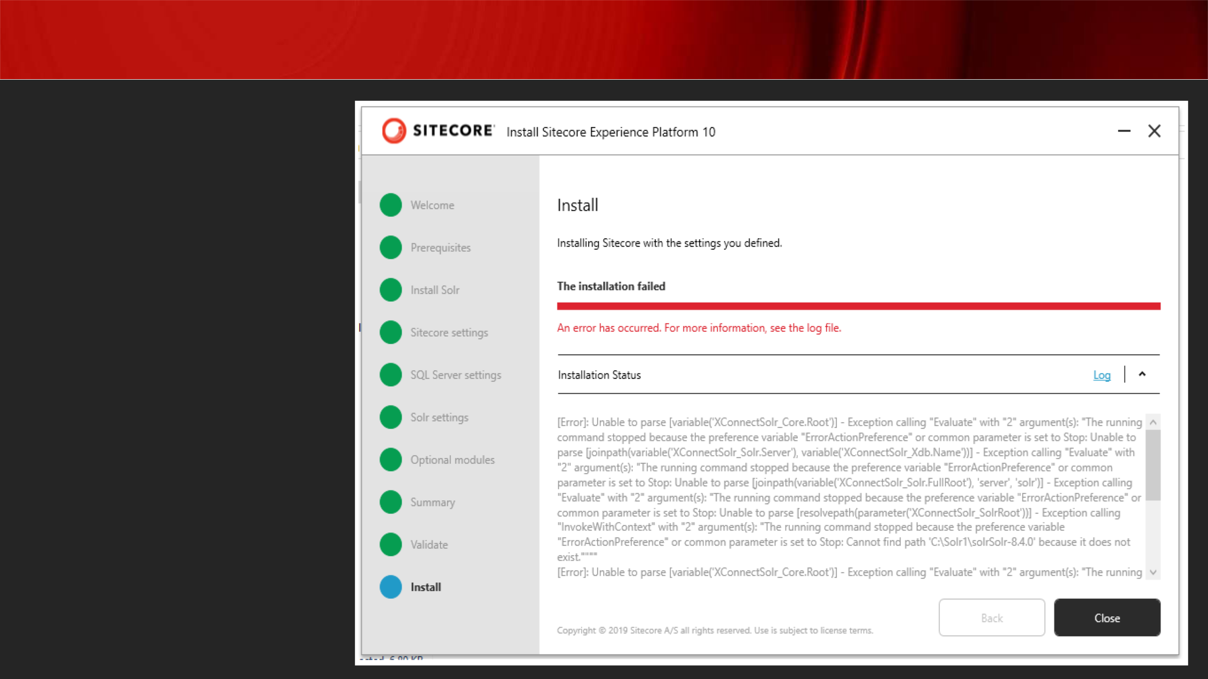SIA Installation Errors

**Non-existent Solr Path:**

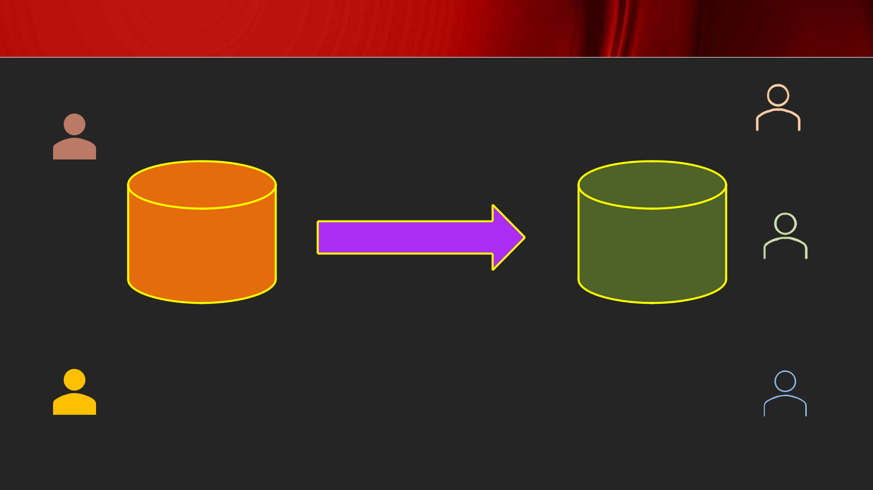Master vs Web DB

**C**

**O**

|  |  |  |  |  |  |
| --- | --- | --- | --- | --- | --- |
| **N** |  |  |  | **L** |  |
| **T** |  |  |  | **I** |  |
| **E** |  |  |  | **V** |  |
| **N** |  |  |  | **E** |  |
| **T** | Master | Publish | Web |  |  |
|  | **U** |  |
|  |  |  |  |  |
| **E** |  |  |  | **S** |  |
| **D** | **Unpublished Content** |  |  | **E** |  |
| **I** |  | **Published Content** | **R** |  |
| **T** |  |  |  | **S** |  |
| **O** |  |  |  |  |  |
| **R** |  |  |  |  |  |
| **S** |  |  |  |  |  |

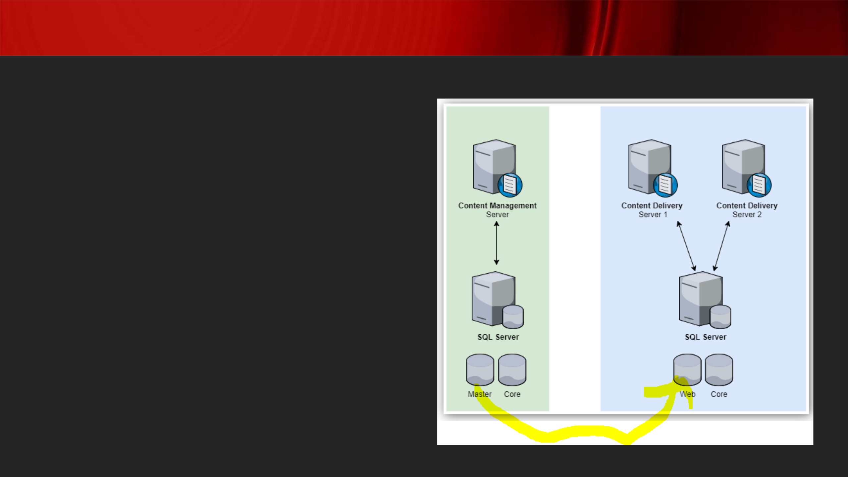Master vs Web DB

**Master DB to edit content while Web DB is used to store live data**

**Content changes made in Web DB will be overwritten by next publish so, always changes must go from master -> web**

**Publishing Wizard:**

**Content Editor**

**Experience Editor**

**Sitecore Desktop**

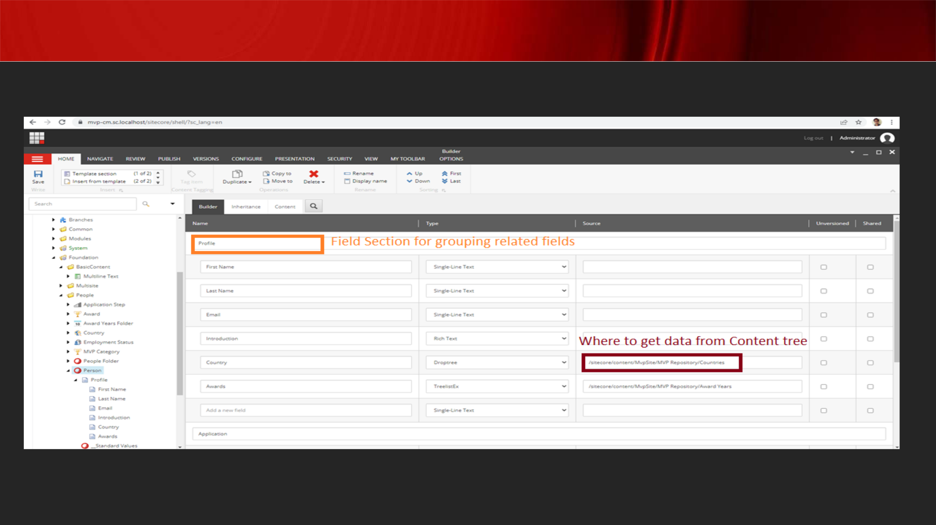Templates or Data templates

**Nothing but data structures**

**When you select types like multilist / droptree / treelist, you must set the source too**

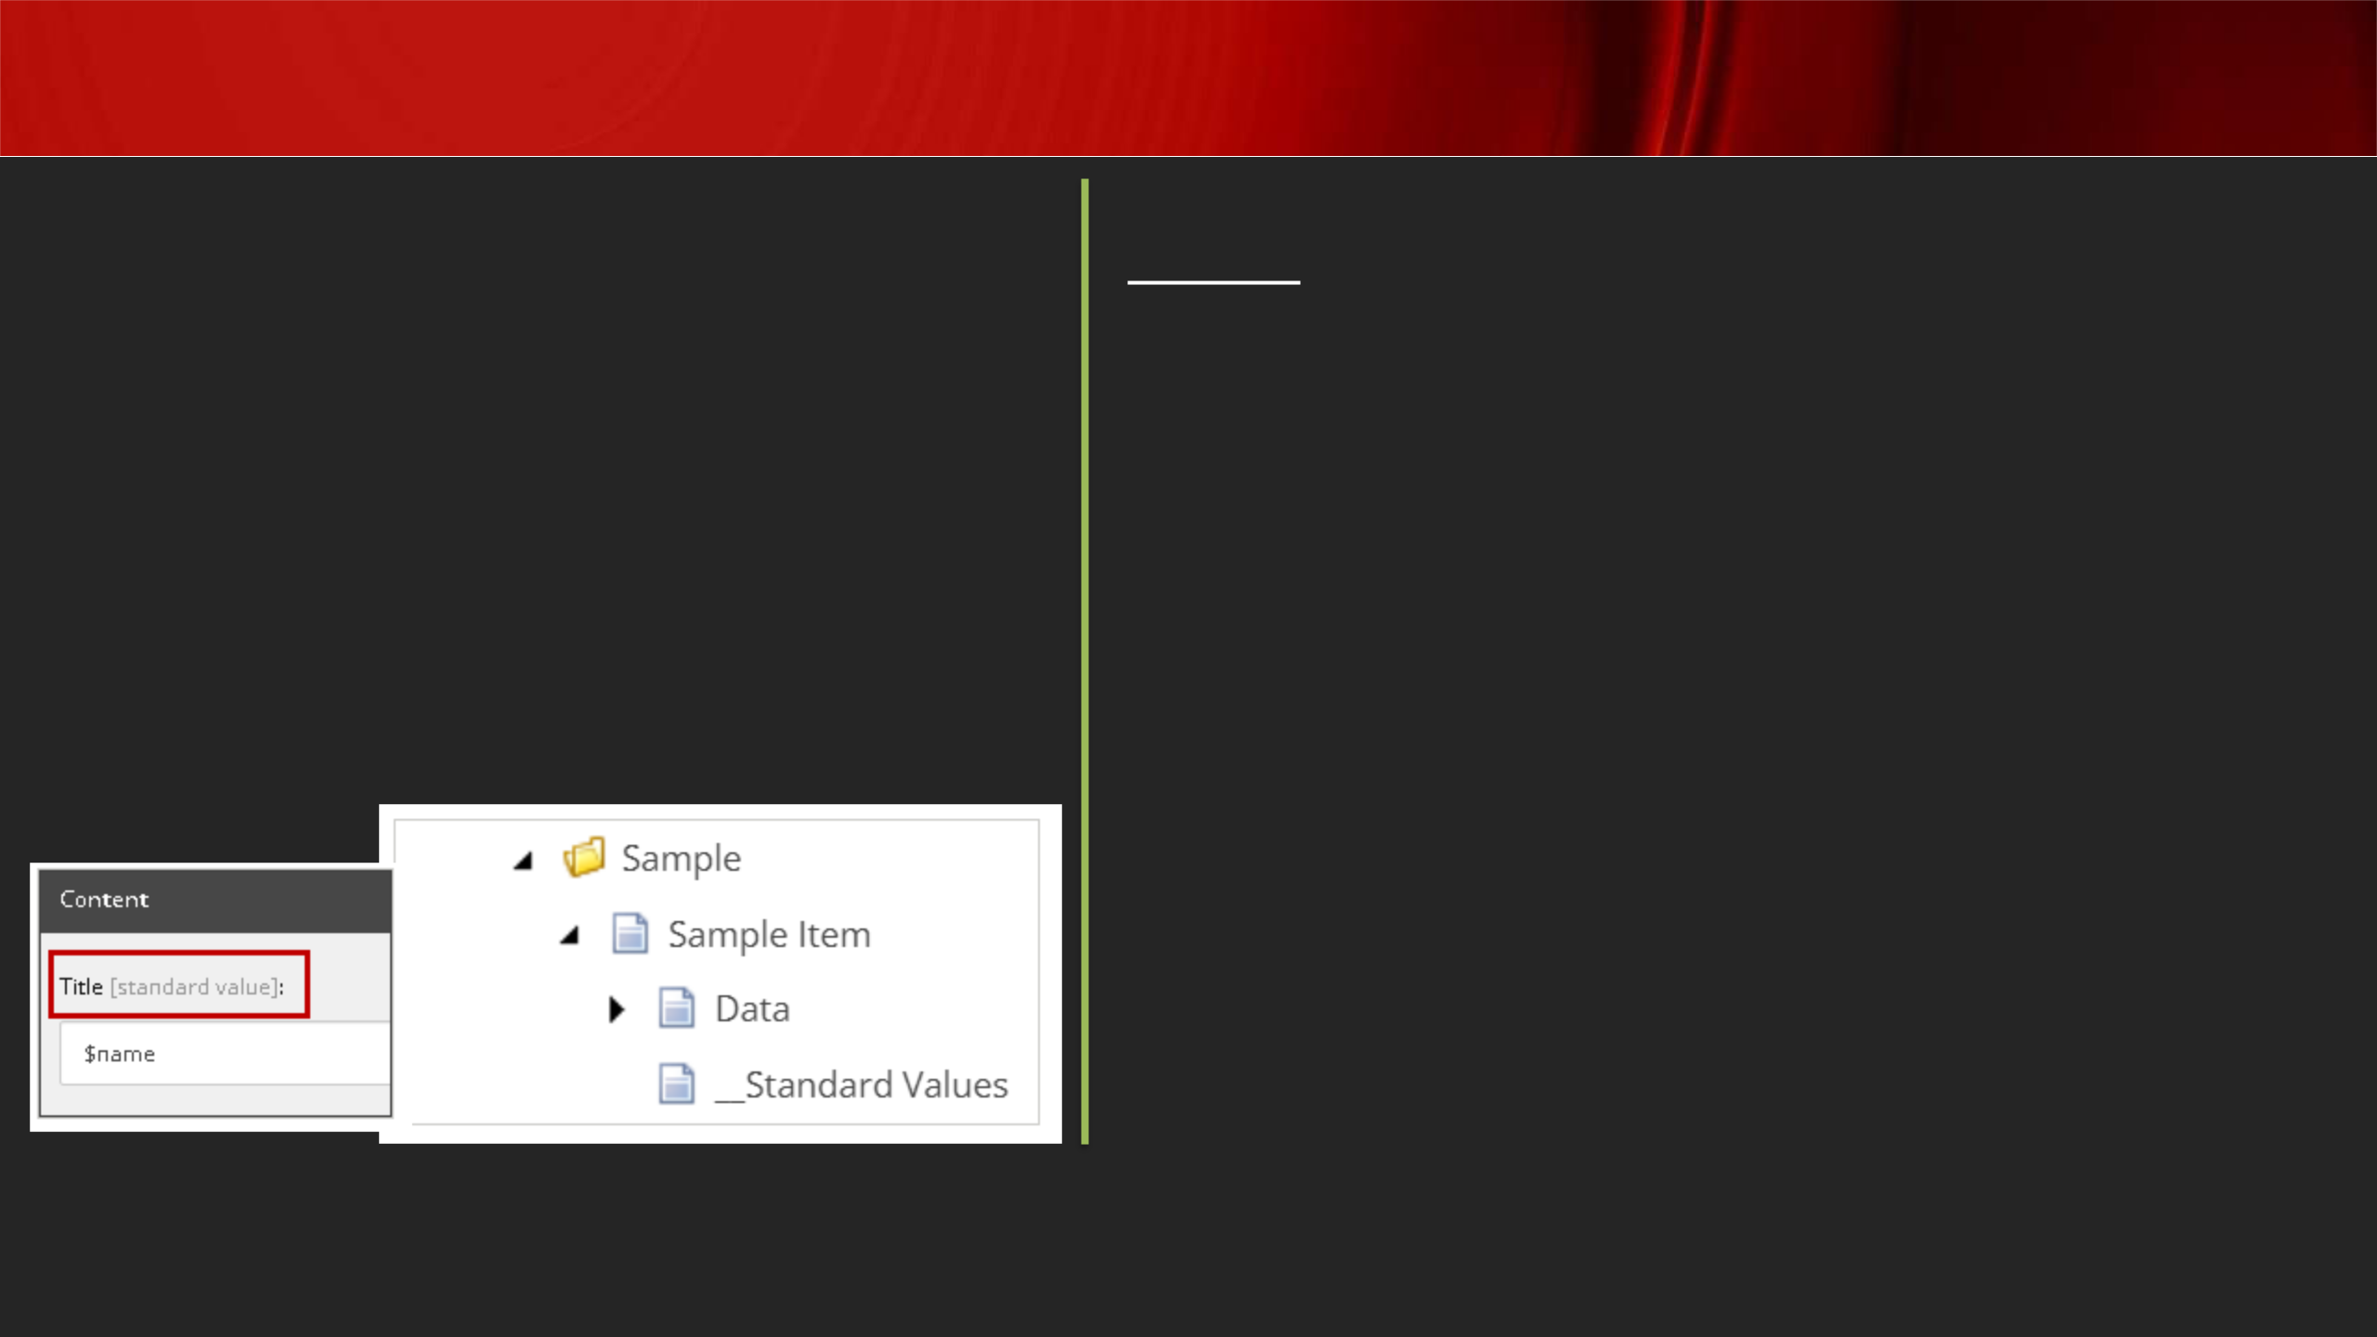

Standard Values

* **Default value for field**
* **Fallback value when field value is null**

***Good practice to setup Presentation***

***Details since it standardizes content***

***creation process***

**Tokens:**

**$name: The name of the item**

**$id: The ID of the item**

**$parentid: The ID of the parent item**

**$parentname: The name of the parent item**

**$date: The system date (yyyyMMdd)**

**$time: The system time (HHmmss)**

**$now: The date and time (yyyyMMddTHHmmss)**

[**https://doc.sitecore.com/xp/en/developers/100/sitecore-experience-manager/standard-values.html**](https://doc.sitecore.com/xp/en/developers/100/sitecore-experience-manager/standard-values.html)

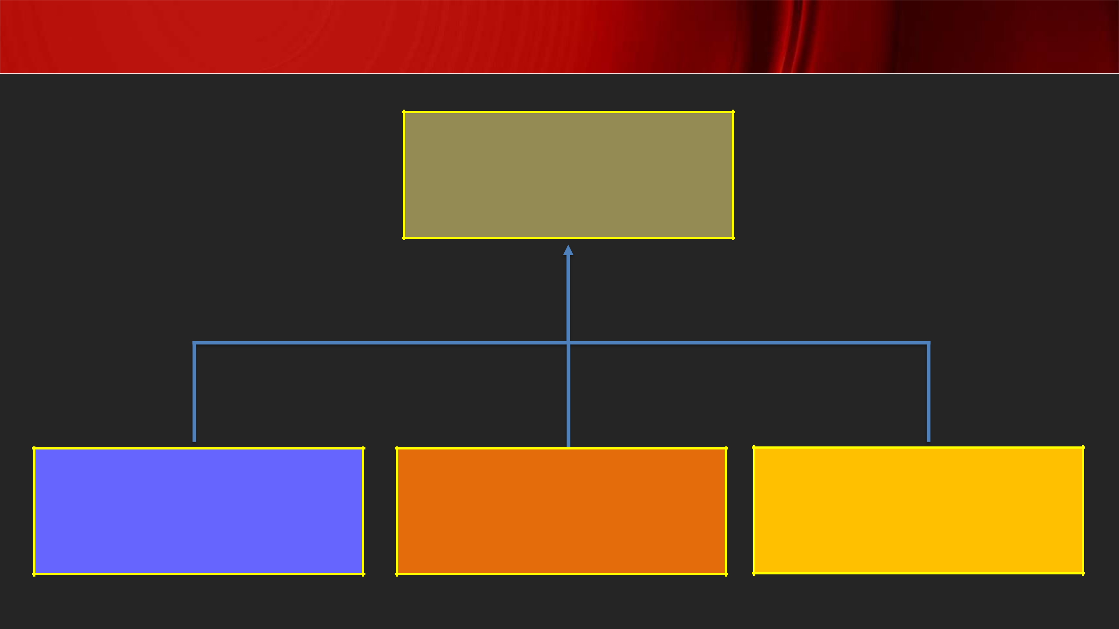Template Inheritance

**Component**

* Title
* Description

**Banner**

* Blurb
* CTA
* Image

**Article**

* Author
* Copyright
* Publish Date

**Rating**

* Score
* Reviewer
* Date of Review

**Note: If a field with same name across two templates points to two different source, then it is not a candidate for inheritance**

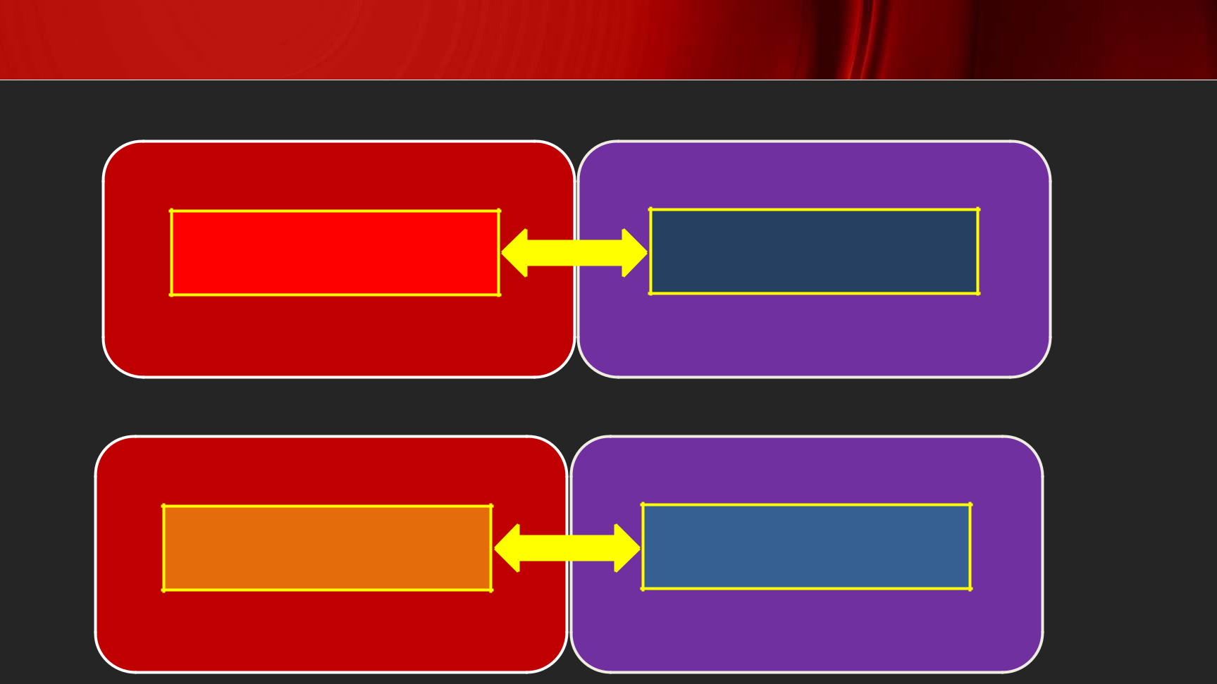Sitecore MVC Concepts

**Layout:**

Sitecore

Layout Definition Item

**View Rendering:**

Sitecore

Rendering Definition Item

Visual Studio

Layout File (.cshtml)

Visual Studio

View File (.cshtml)

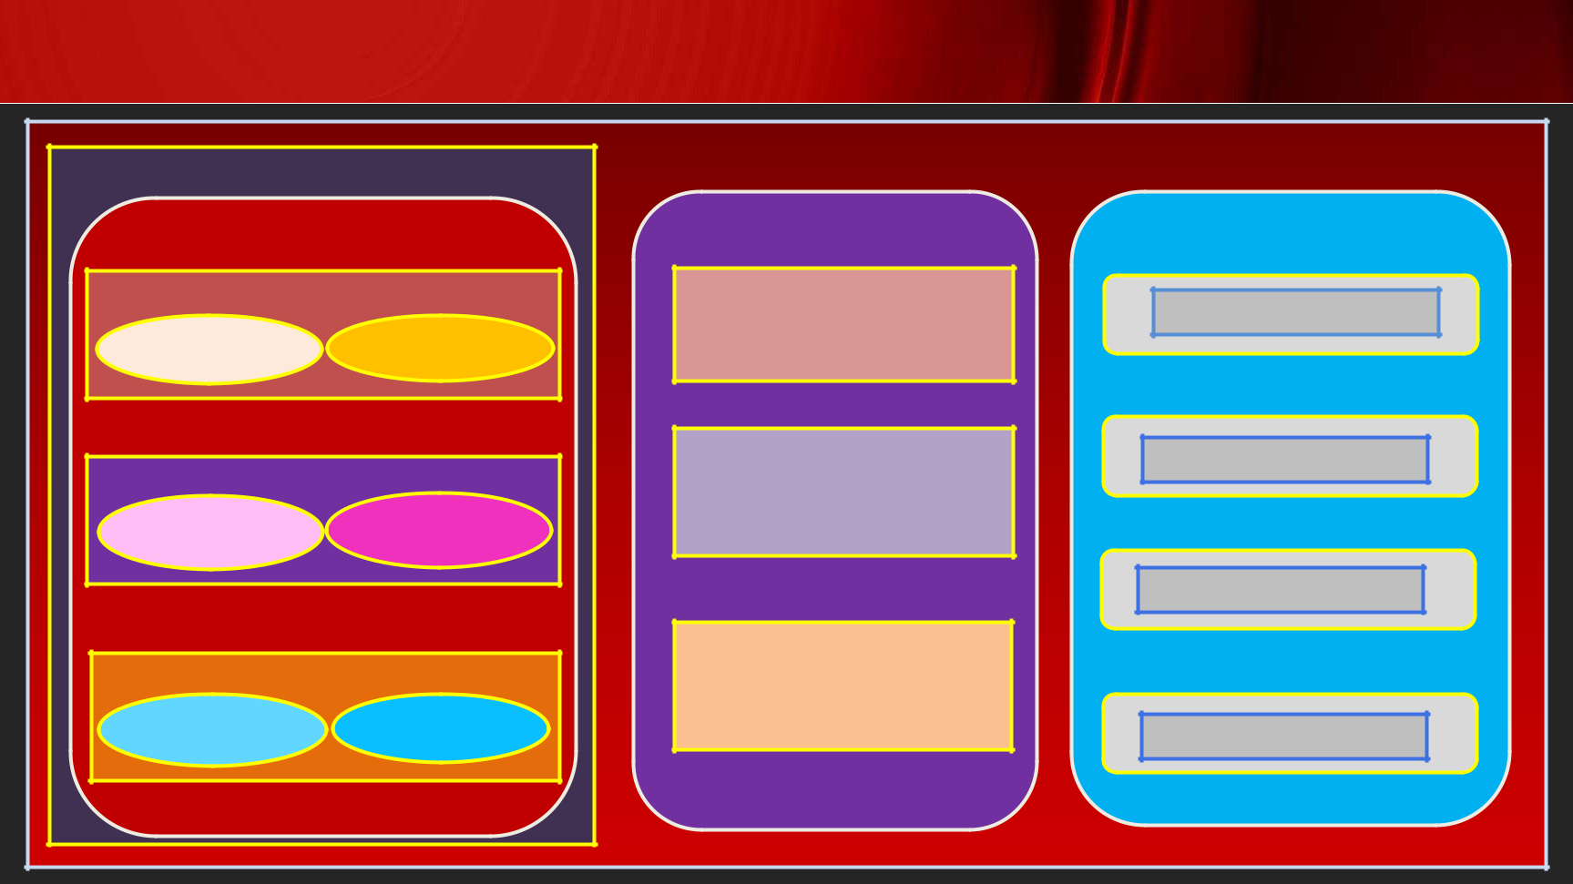Sitecore MVC Concepts

Layout Details

Layout Definition

Placeholder Definition

Rendering Data

Definition Source

Placeholder Definition

Rendering Data

Definition Source

Placeholder Definition

Rendering Data

Definition Source

Layout (.cshtml)

Placeholder

Placeholder

Placeholder

Sitecore Context

Rendering

(.cshtml)

Template Field

Template Field

Template Field

Template Field

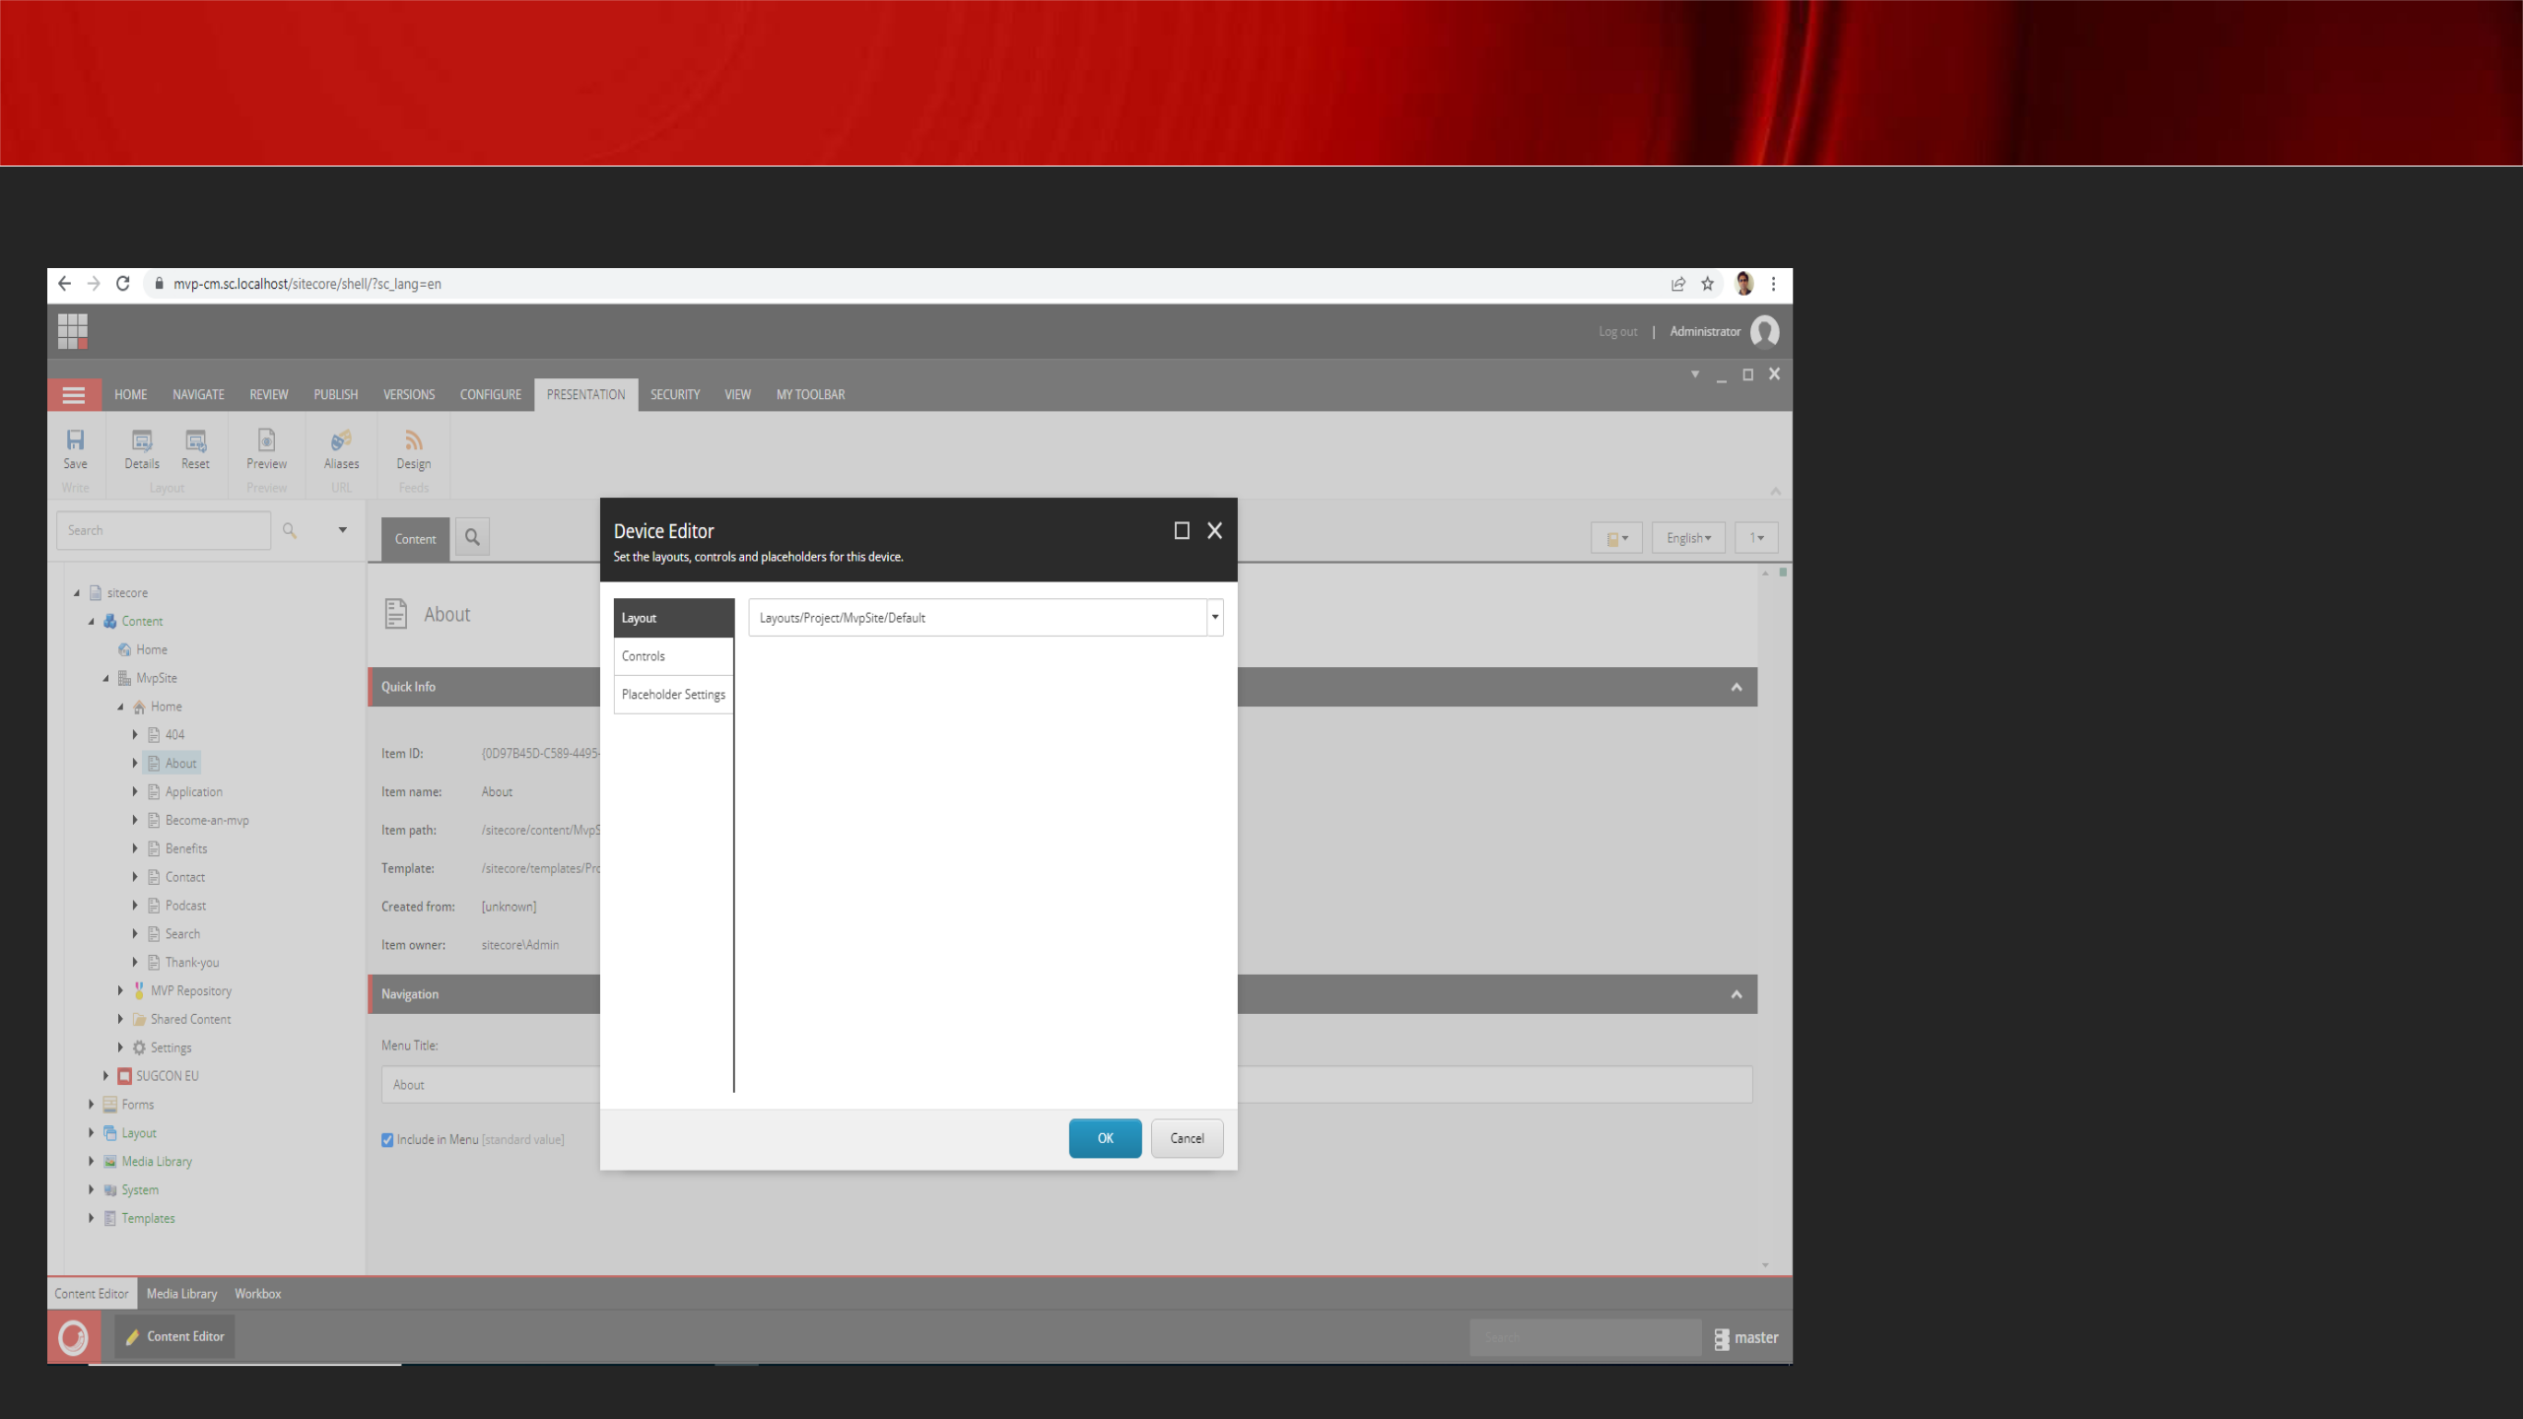Presentation Details

**For page to be visible,**

**the following are important:**

* **Layout**
* **Controls**

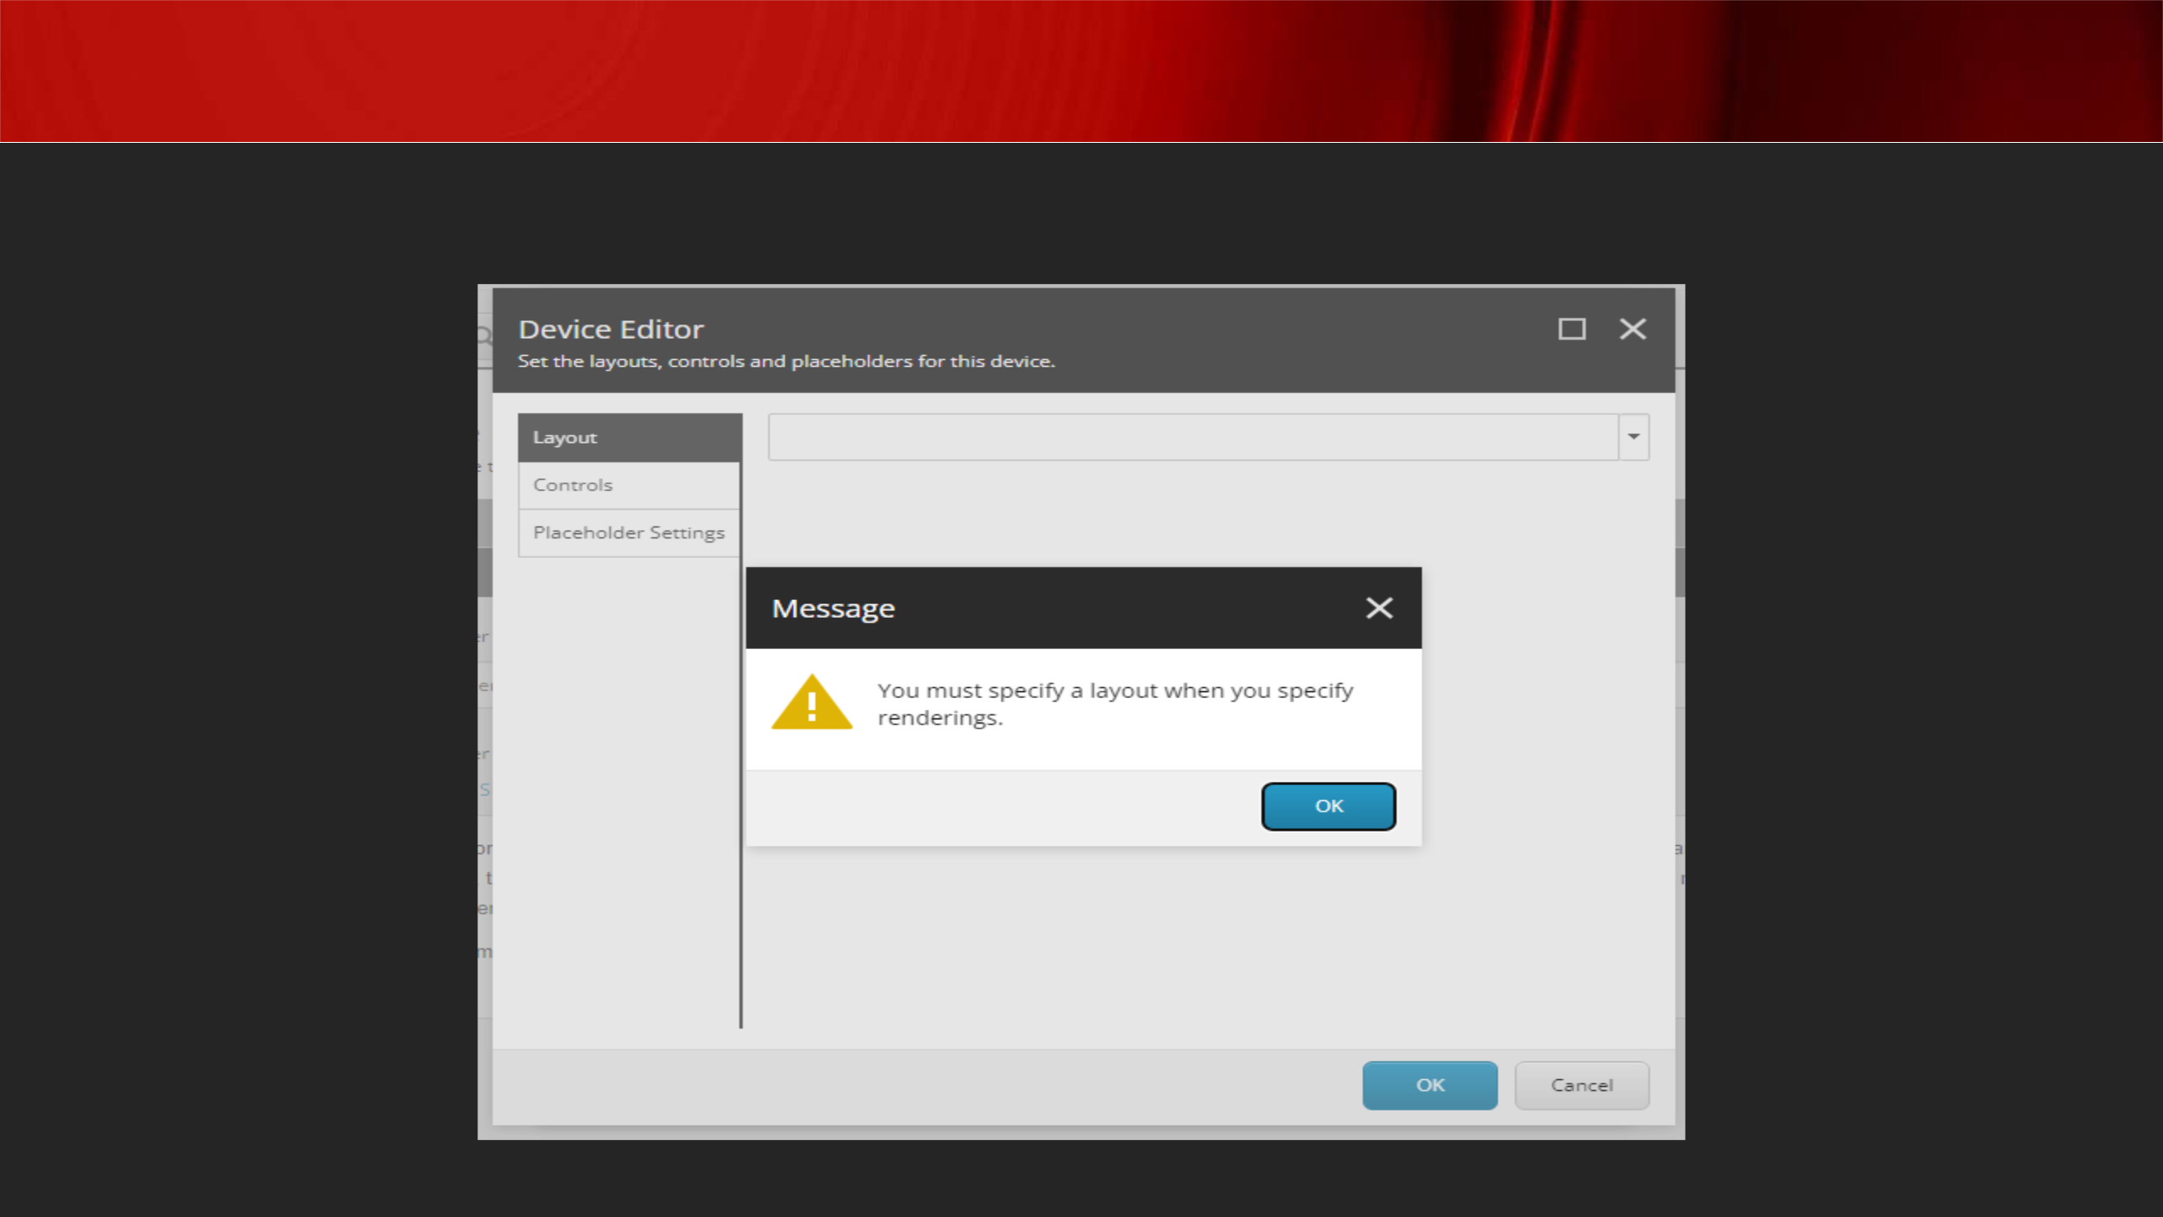Presentation Details

**Layout mandatory for Presentation Details with controls:**

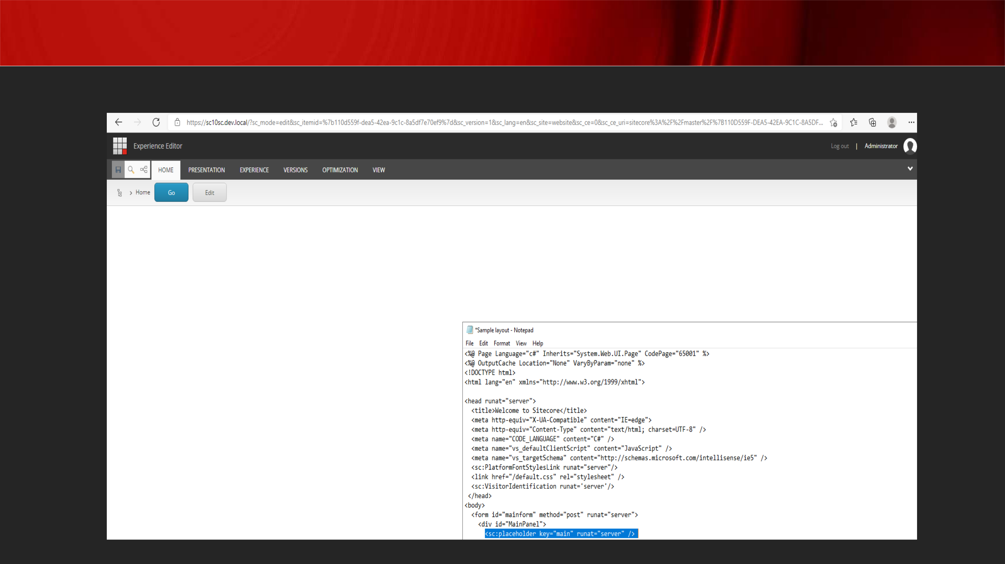Presentation Details

**Removing “main” placeholder in cshtml does not display the rendering within:**

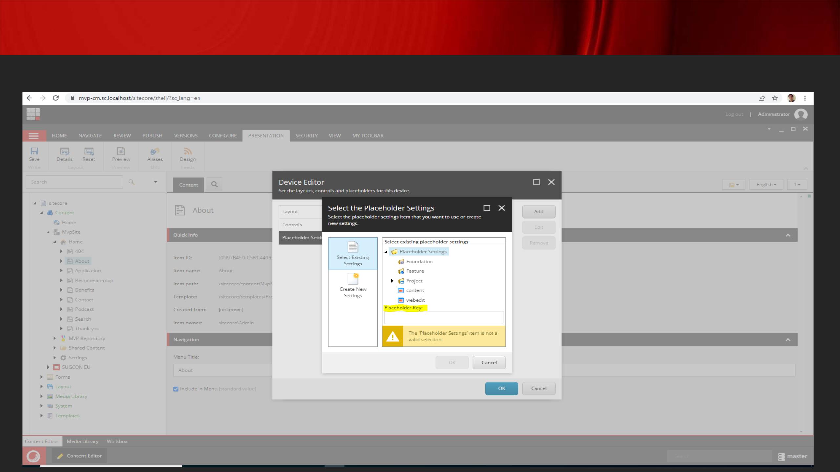Presentation Details

**Placeholder is uniquely identified by Placeholder key**

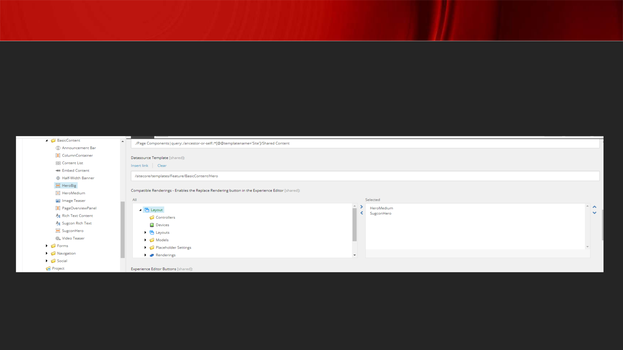

**Rendering**

* + **Checkbox or tree list cannot be rendered using @Html.Sitecore.Field()**
* **A Compatible Rendering is a component that can be replaced with another component providing both use the same data source type (or no data source at all) e.g. use the same type of data.**

[**https://mattneil.co.uk/2017/01/17/compatible-renderings-in-sitecore/**](https://community.sitecore.com/community?id=community_question&sys_id=64a4e7ed1b0770d0b8954371b24bcbb0#14463)

[**https://community.sitecore.com/community?id=community_question&sys_id=64a4**](https://community.sitecore.com/community?id=community_question&sys_id=64a4e7ed1b0770d0b8954371b24bcbb0#14463)[**e7ed1b0770d0b8954371b24bcbb0#14463**](https://community.sitecore.com/community?id=community_question&sys_id=64a4e7ed1b0770d0b8954371b24bcbb0#14463)

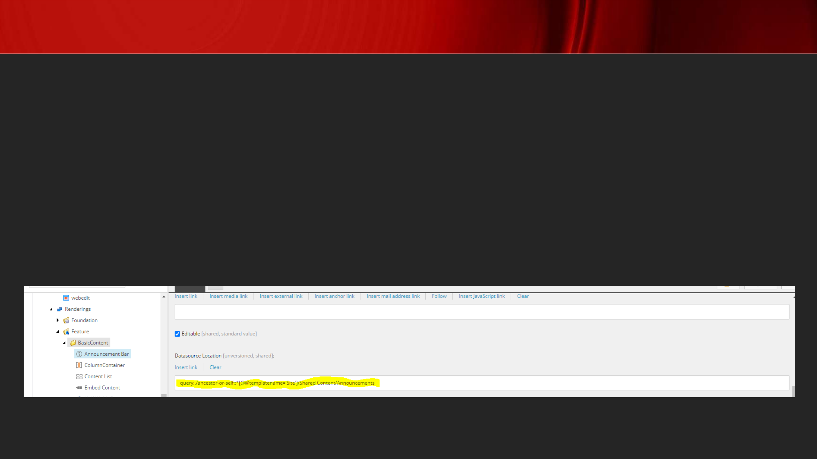General Sitecore MVC titbits

* **Dynamic component binding useful in personalization**
* **Static component binding useful for fixed header or footer and disallows content editors to remove the component**
* **Configure rendering Datasource location to restrict content editors to select content from a specific location in the content tree**
* **Configure Datasource template to filter content items based on a template**

[**https://www.jondjones.com/learn-sitecore-cms/sitecore-developers-guide/sitecore-and-mvc/how-to-make-sitecore-use-a-mvc-controller-controller-renderings-explained/**](https://www.jondjones.com/learn-sitecore-cms/sitecore-developers-guide/sitecore-and-mvc/how-to-make-sitecore-use-a-mvc-controller-controller-renderings-explained/)

Insert Options

***Good practice to setup insert options on standard values of an item template* You can set insert options on an item in the content tree as well**

**The former allows inserting only specific type of items while the latter option is useful when you want to add additional items**

[**https://doc.sitecore.com/xp/en/developers/91/sitecore-experience-manager/insert-options.html#:~:text=Sitecore%20administrators%20and%20developers%20configur**](https://doc.sitecore.com/xp/en/developers/91/sitecore-experience-manager/insert-options.html#:~:text=Sitecore%20administrators%20and%20developers%20configure,the%20user%20could%20possibly%20insert.)[**e,the%20user%20could%20possibly%20insert.**](https://doc.sitecore.com/xp/en/developers/91/sitecore-experience-manager/insert-options.html#:~:text=Sitecore%20administrators%20and%20developers%20configure,the%20user%20could%20possibly%20insert.)

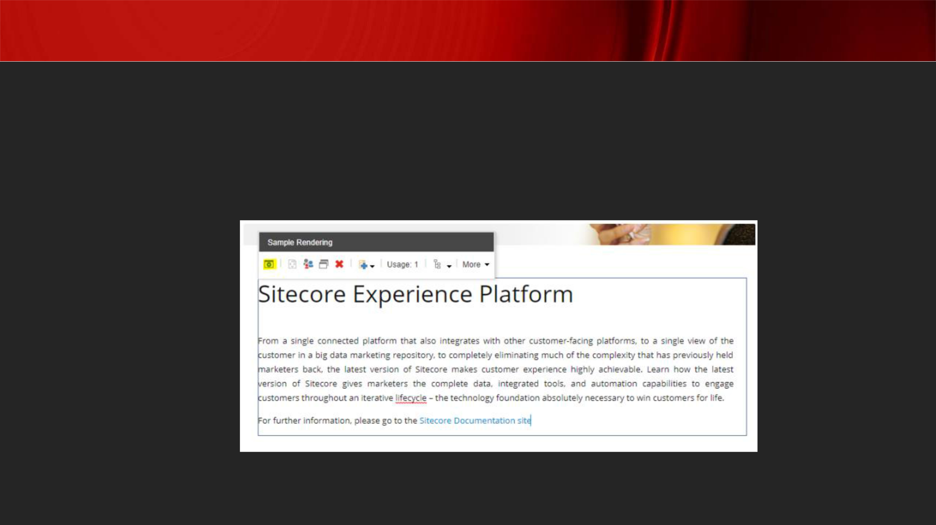Field Editor Button

**Field Editor Buttons allow you to enhance the user experience for a given component. There maybe some field options that are not available in Experience Editor and you have to edit the content via the Content Editor. This overall is not a good user experience. This is where Experience Editor Buttons help and improve the Sitecore user experience.**

[**https://mattneil.co.uk/2017/07/10/sitecore-experience-editor-buttons-and-their-**](https://mattneil.co.uk/2017/07/10/sitecore-experience-editor-buttons-and-their-uses/)

[**uses/**](https://mattneil.co.uk/2017/07/10/sitecore-experience-editor-buttons-and-their-uses/)

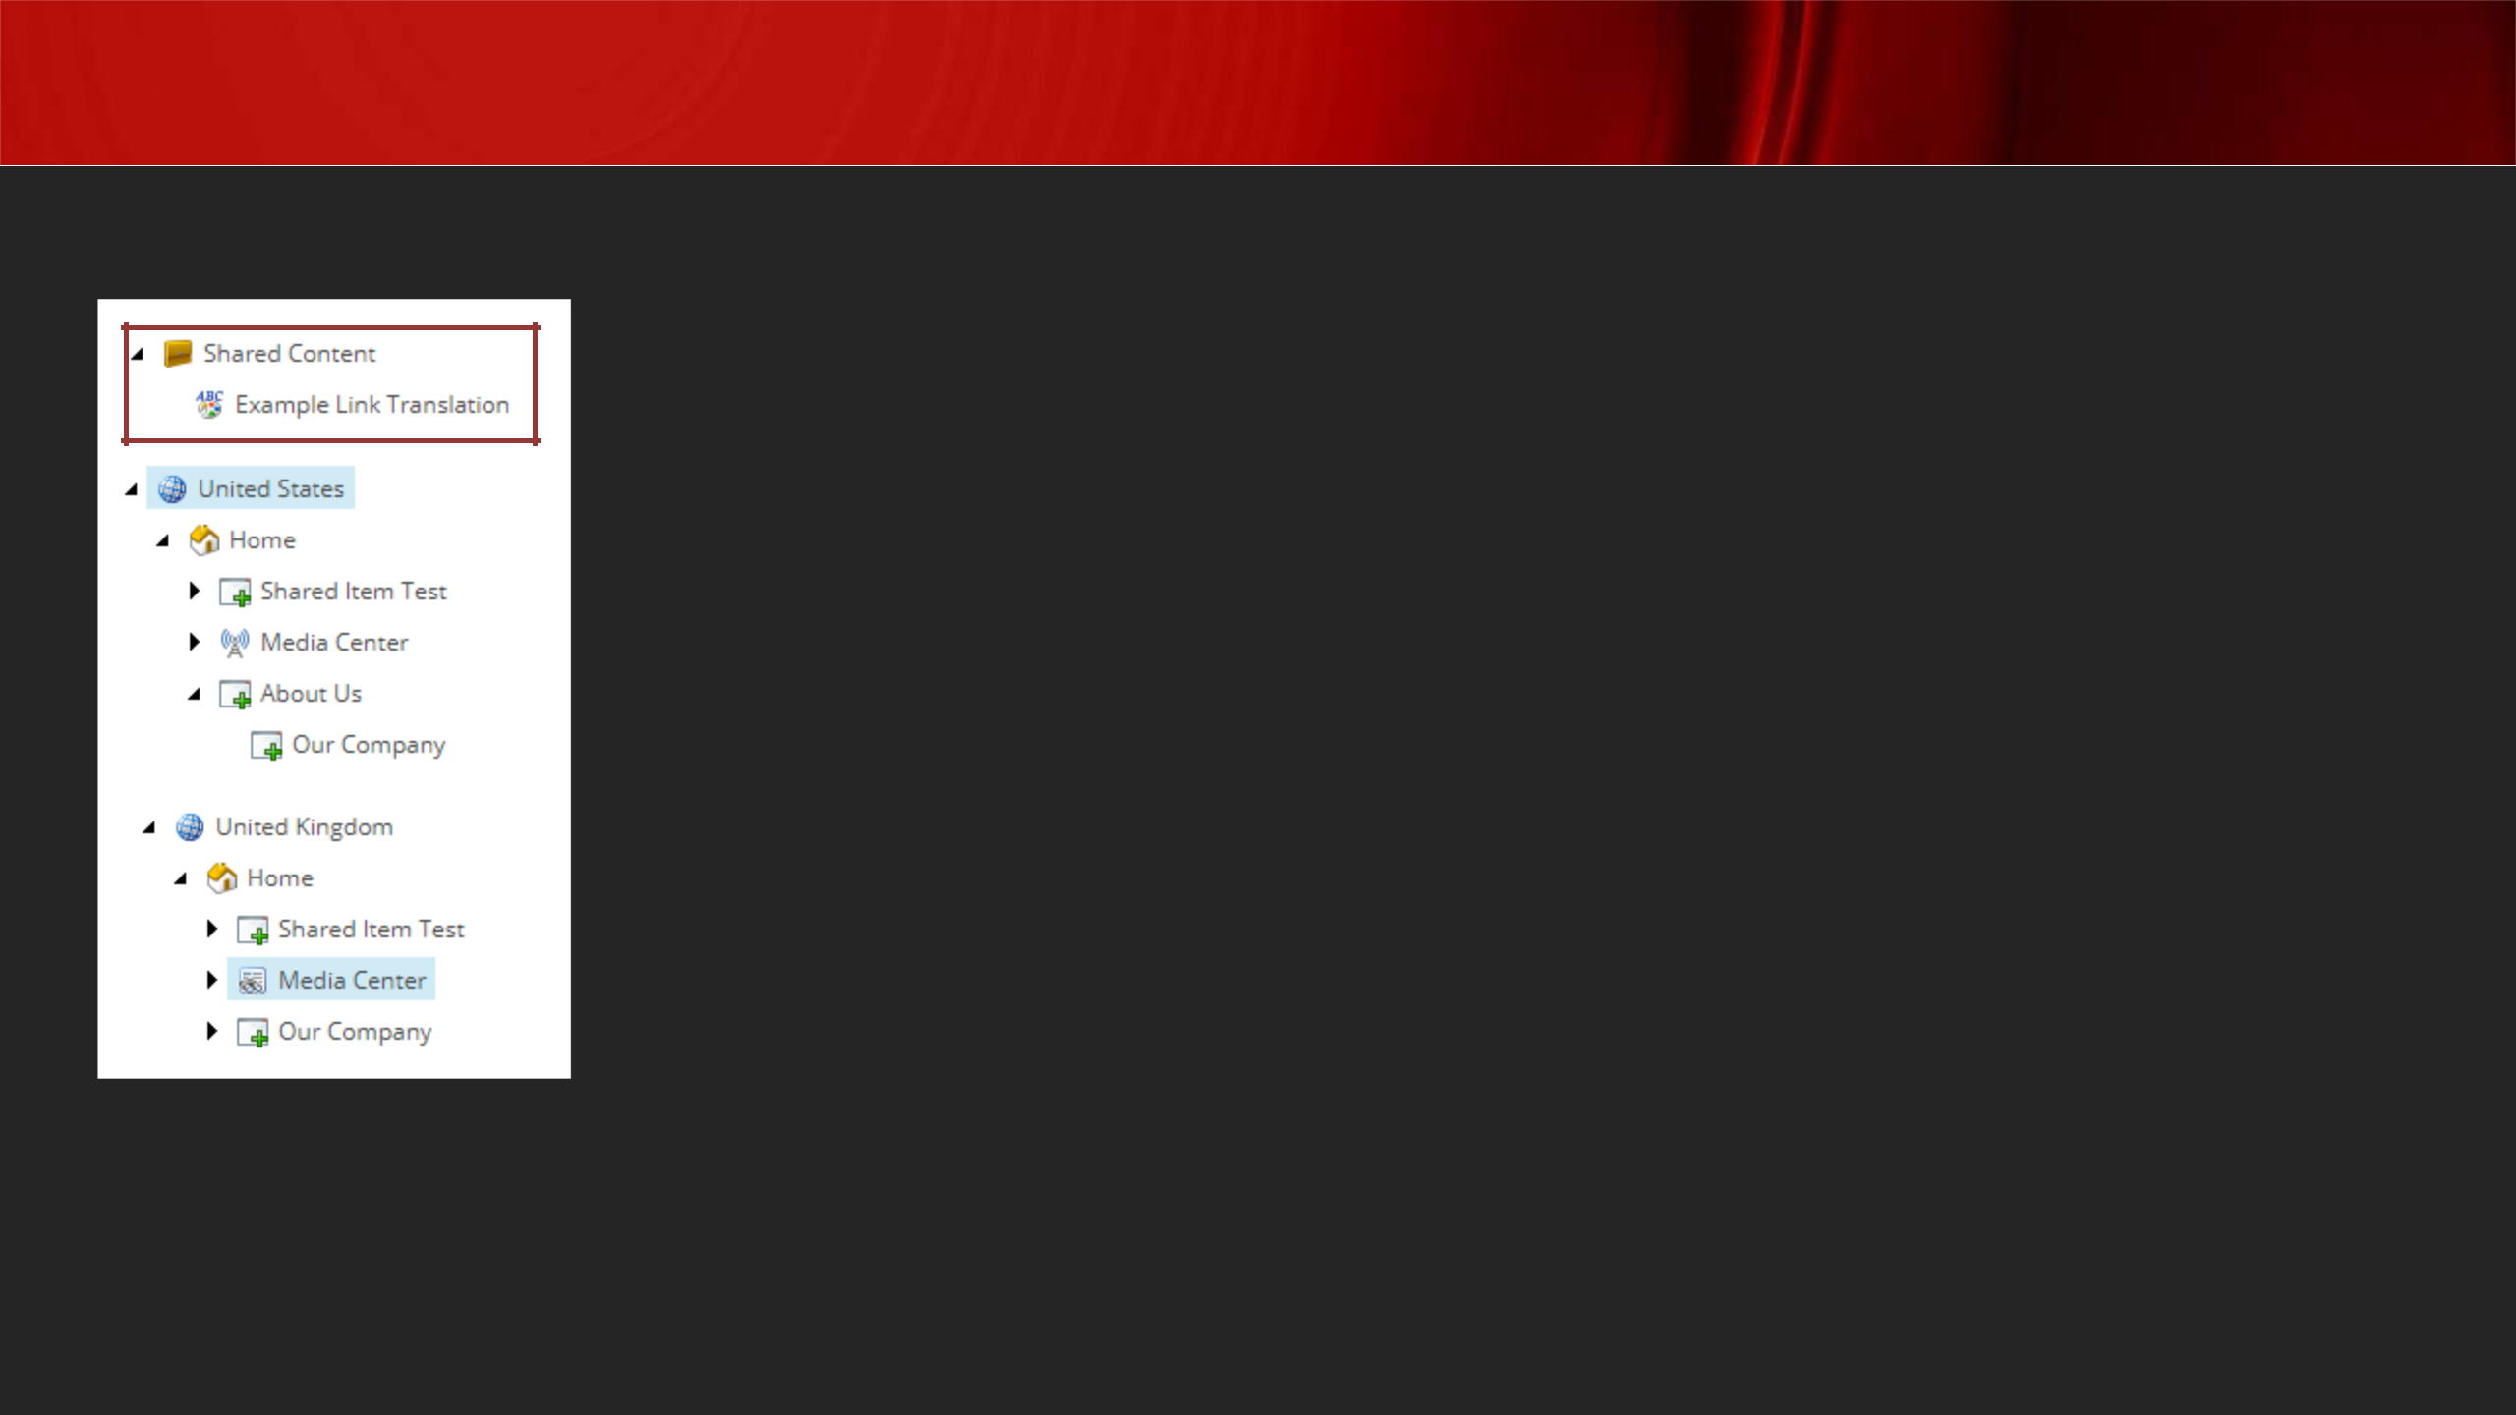Sharing content between Sites

***Best practice:***

***Shared Content should be stored outside of any one site's content tree structure.***

[**https://byteium.com/2019/08/content-sharing-and-links-in-sitecore**](https://byteium.com/2019/08/content-sharing-and-links-in-sitecore)

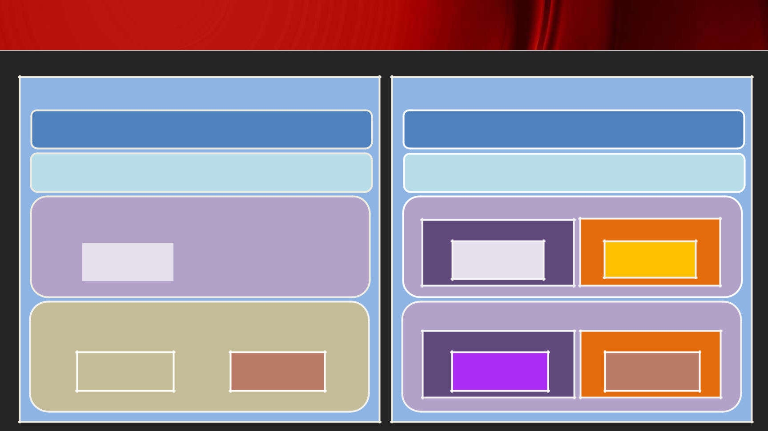Static vs Dynamic Placeholder

main

heading

navigation

Body-2-col

main

heading

navigation

Body-2-col

|  |  |  |  |  |  |  |
| --- | --- | --- | --- | --- | --- | --- |
| left | | |  |  | right | |
|  |  | |  |  |  |  |
|  | Banner |  |  |  | News |  |
|  |  |  |  |  |  |  |
|  |  |  |  |  |  |  |

|  |  |  |  |  |  |  |  |
| --- | --- | --- | --- | --- | --- | --- | --- |
|  | Body- | | 2-col-second |  |  |  |  |
|  |  |  | |  |  |  |  |
|  | left | | |  |  |  | right |
|  |  |  | Rating |  |  |  | Testimonial |
|  |  |  |  |  |  |  |  |
|  |  |  |  |  |  |  |  |

left

Banner

Body-2-col

left

Rating

right

News

right

Testimonial

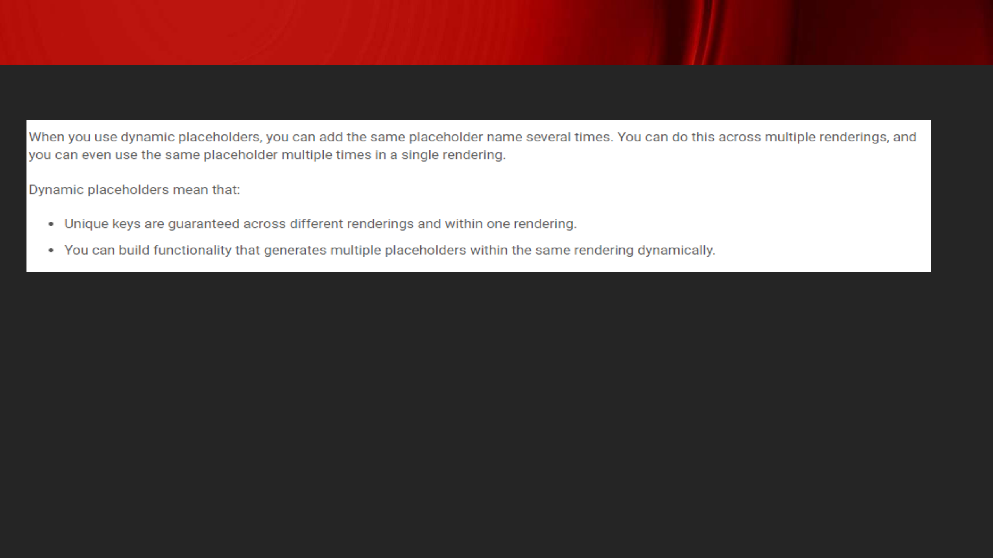Dynamic Placeholder

**Dynamic placeholders: Same key but unique content**

[**https://doc.sitecore.com/xp/en/developers/92/sitecore-experience-manager/dynamic-**](https://doc.sitecore.com/xp/en/developers/92/sitecore-experience-manager/dynamic-placeholders.html)

[**placeholders.html**](https://doc.sitecore.com/xp/en/developers/92/sitecore-experience-manager/dynamic-placeholders.html)

[**https://sitecorediaries.org/2019/12/04/what-is-layout-in-sitecore-and-how-can-we-**](https://sitecorediaries.org/2019/12/04/what-is-layout-in-sitecore-and-how-can-we-create-it/#:~:text=Layouts%20are%20the%20scaffolding%20for,one%20can%20plug%20component%20renderings.)

[**create-**](https://sitecorediaries.org/2019/12/04/what-is-layout-in-sitecore-and-how-can-we-create-it/#:~:text=Layouts%20are%20the%20scaffolding%20for,one%20can%20plug%20component%20renderings.)

[**it/#:~:text=Layouts%20are%20the%20scaffolding%20for,one%20can%20plug%20compon**](https://sitecorediaries.org/2019/12/04/what-is-layout-in-sitecore-and-how-can-we-create-it/#:~:text=Layouts%20are%20the%20scaffolding%20for,one%20can%20plug%20component%20renderings.)

[**ent%20renderings.**](https://sitecorediaries.org/2019/12/04/what-is-layout-in-sitecore-and-how-can-we-create-it/#:~:text=Layouts%20are%20the%20scaffolding%20for,one%20can%20plug%20component%20renderings.)

[**https://sitecorediaries.org/2019/12/09/sitecore-dynamic-placeholders/**](https://sitecorediaries.org/2019/12/09/sitecore-dynamic-placeholders/)

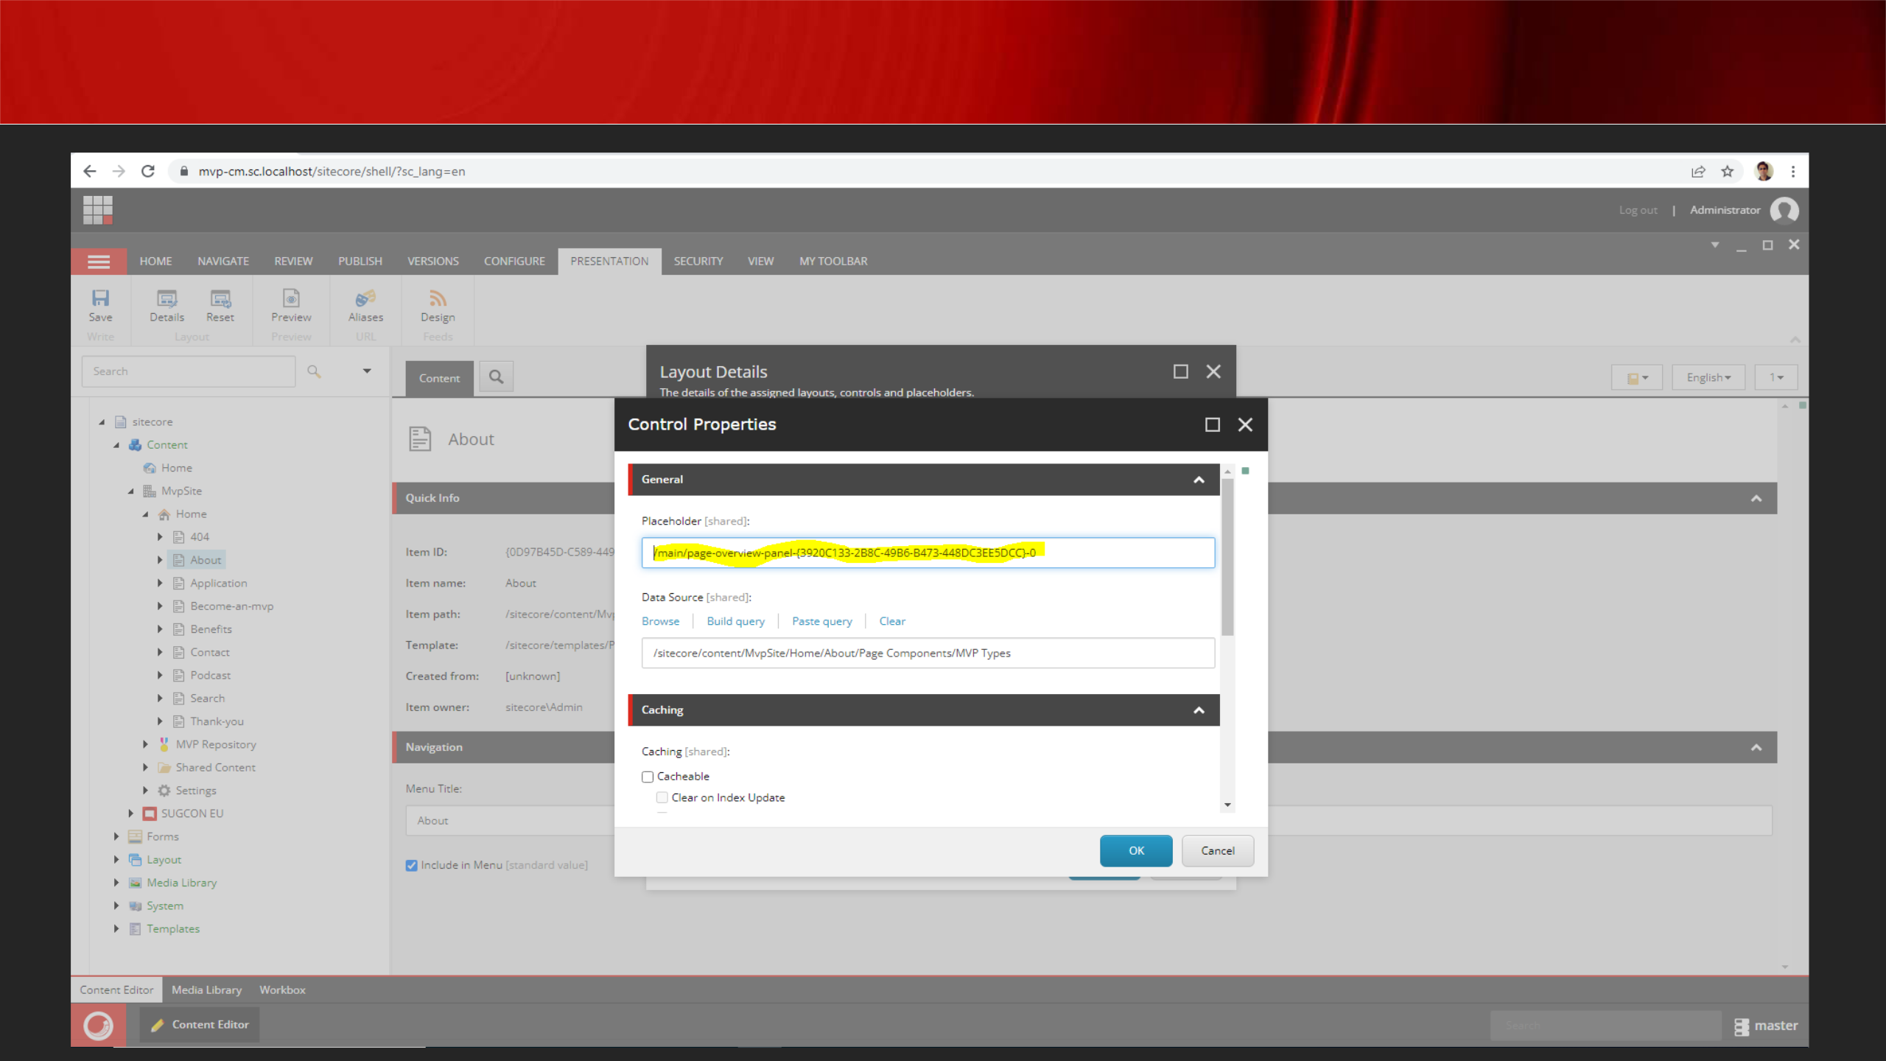Dynamic Placeholder

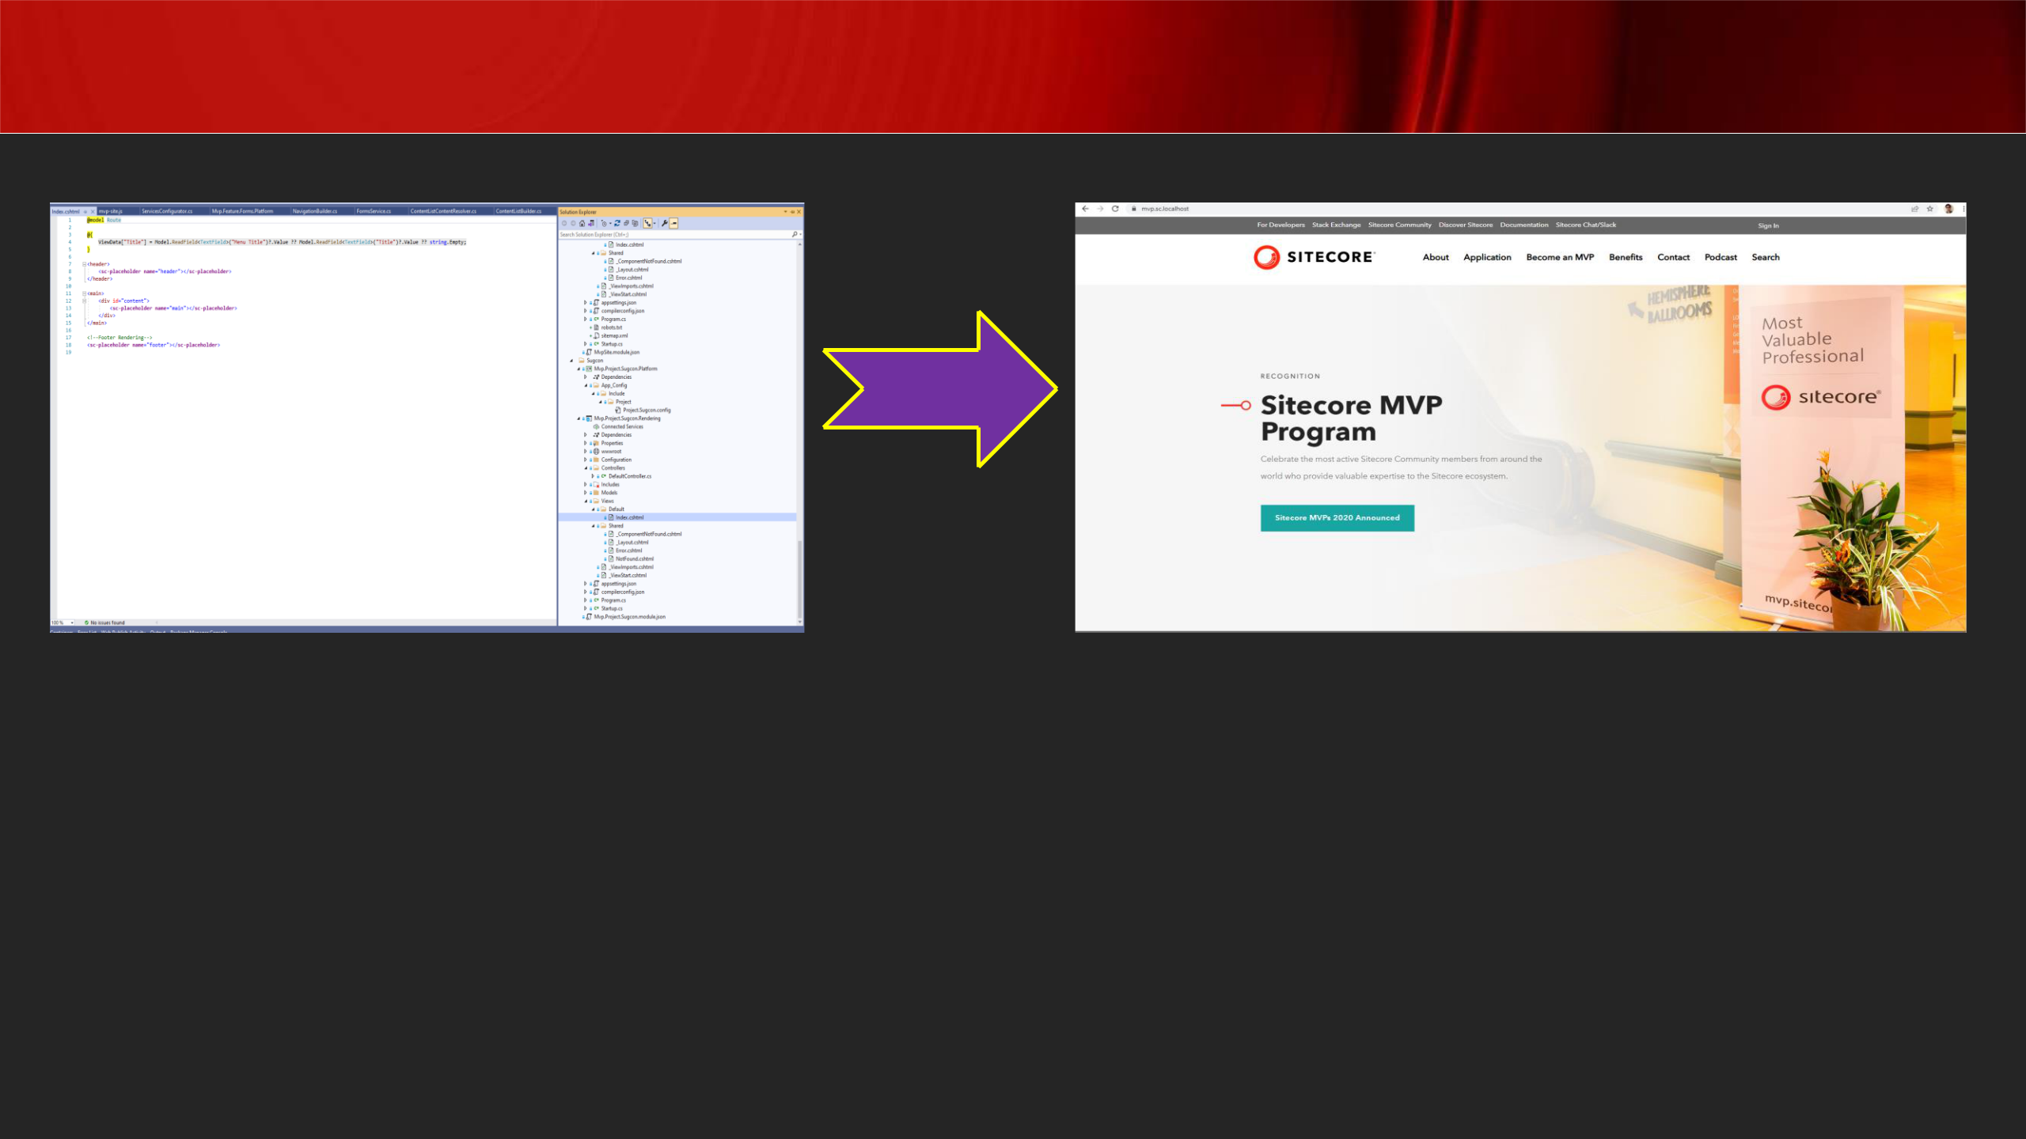**Visual Studio Publish**

Code

Publish

C:\Source Code C:\inetpub\wwwroot\<deploy folder>

**Note: Code publish different from Content editor publish! Also, remember that you can manually copy cshtml files from your solution to the web root folder**

***Tip: While writing C# code, Sitecore.Context is utilised to get Http request details***

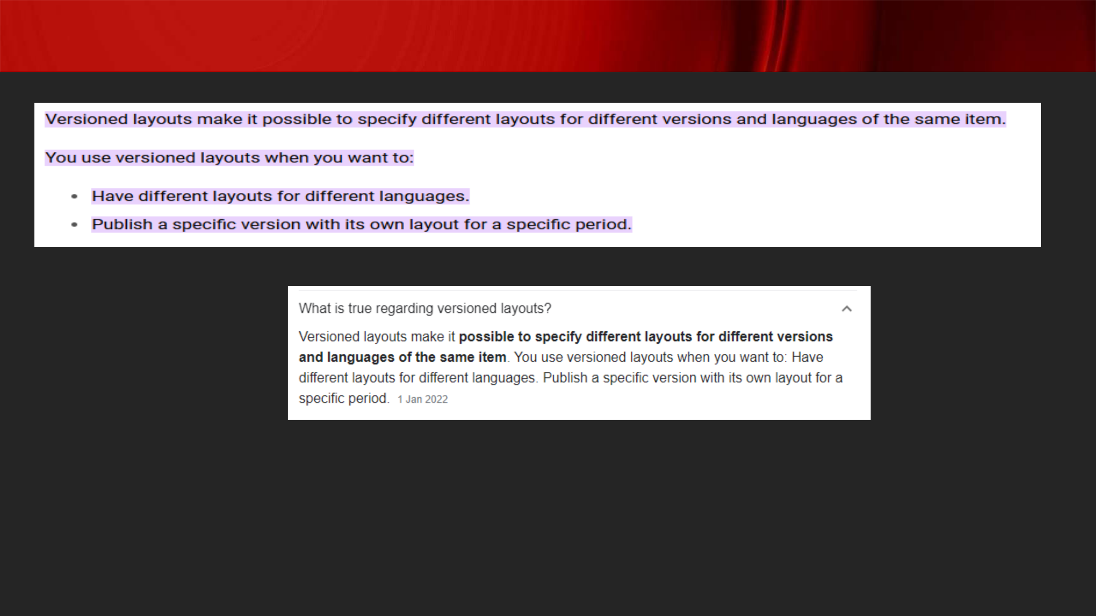Versioned Layouts

[**https://doc.sitecore.com/xp/en/developers/93/sitecore-experience-manager/versioned-layouts.html#:~:text=Versioned%20layouts%20make%20it%20possible,layout%20for%20a**](https://doc.sitecore.com/xp/en/developers/93/sitecore-experience-manager/versioned-layouts.html#:~:text=Versioned%20layouts%20make%20it%20possible,layout%20for%20a%20specific%20period.)[**%20specific%20period.**](https://doc.sitecore.com/xp/en/developers/93/sitecore-experience-manager/versioned-layouts.html#:~:text=Versioned%20layouts%20make%20it%20possible,layout%20for%20a%20specific%20period.)

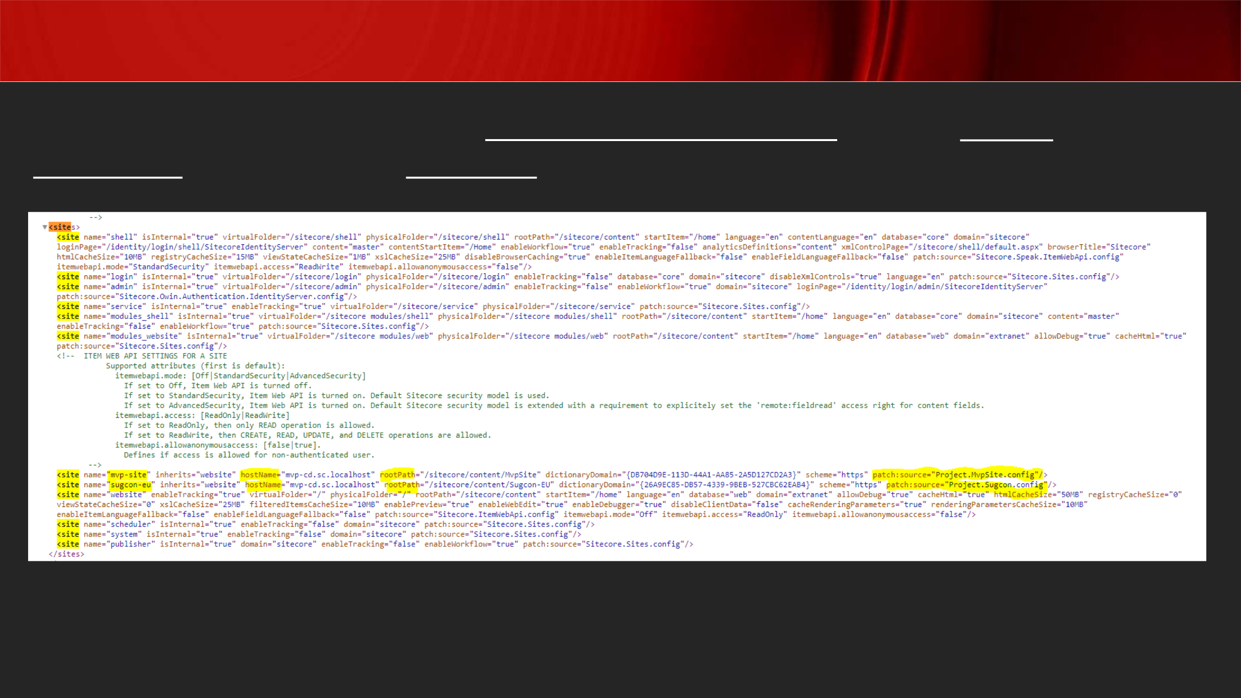Site Definition Patch Config

**Patch file is used to accommodate multiple public-facing sites and used to map home item to corresponding hostname**

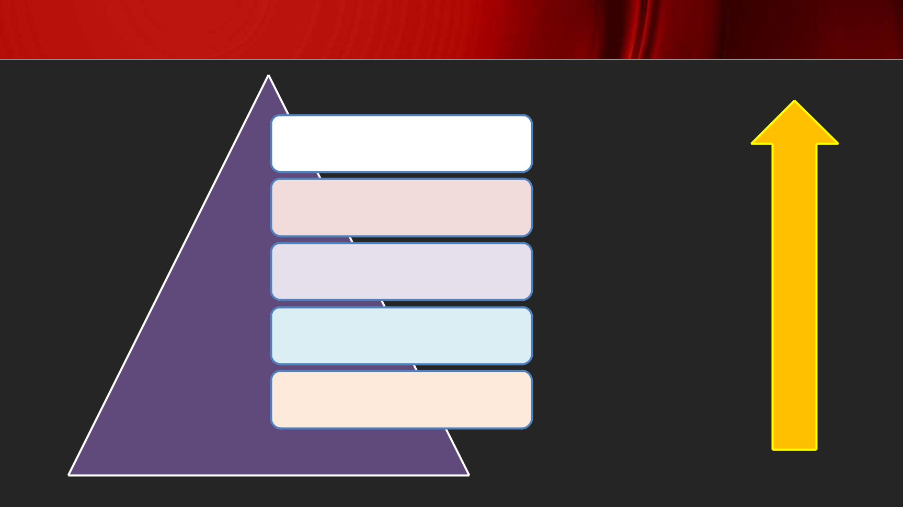Config Files Load Order

Environment Layer

Custom Layer

Modules Layer

Sitecore Layer

Basic System Files

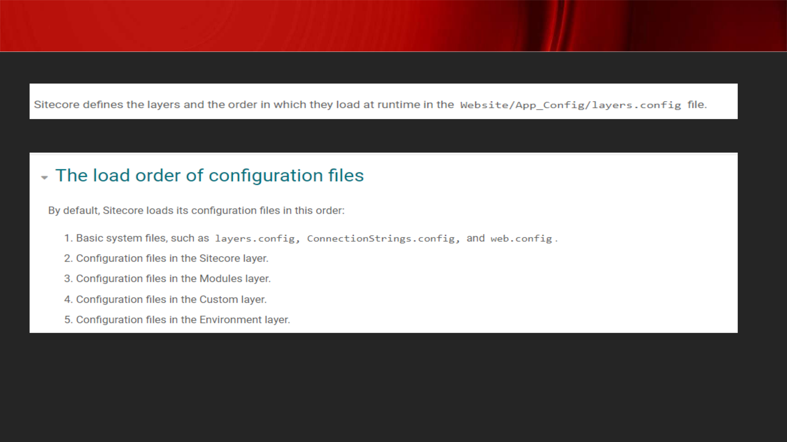Layers/Load Order

[**https://doc.sitecore.com/xp/en/developers/92/platform-administration-and-architecture/configuration-layers.html**](https://doc.sitecore.com/xp/en/developers/92/platform-administration-and-architecture/configuration-layers.html)

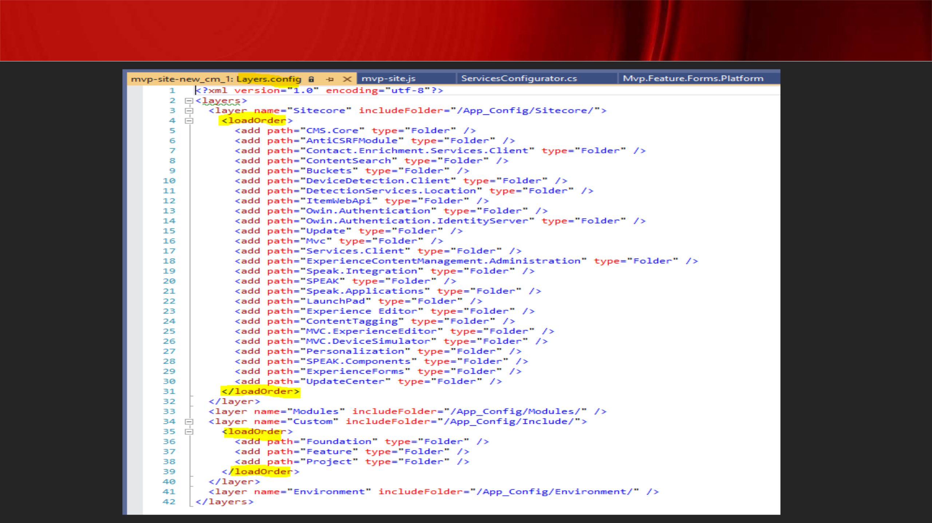Layers Config File

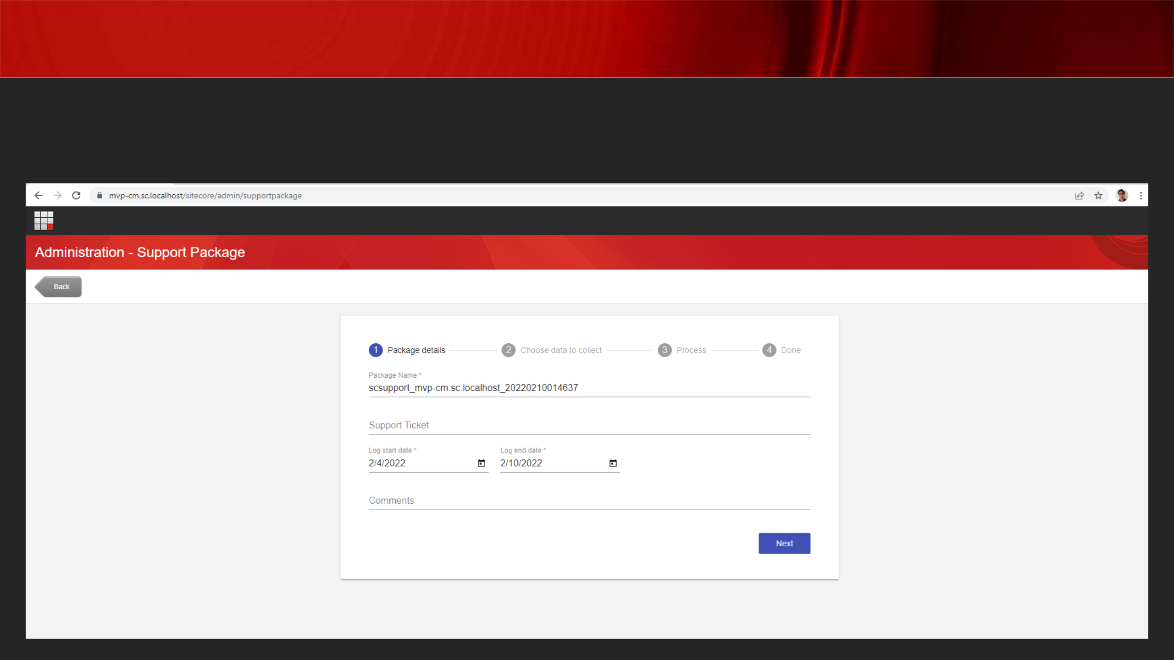Sitecore Support Package

**Purpose: Help Sitecore team replicate an issue without accessing the actual Sitecore environment**

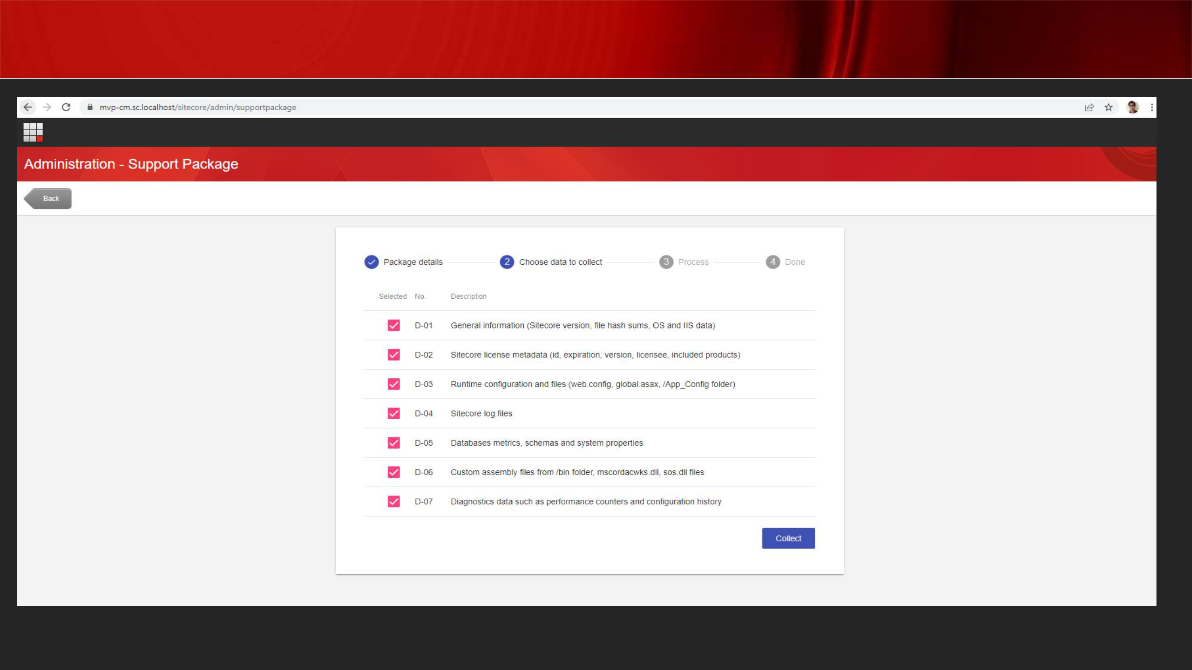Sitecore Support Package

[**https://support.sitecore.com/kb?id=kb_article_view&sysparm_article=KB0406145**](https://support.sitecore.com/kb?id=kb_article_view&sysparm_article=KB0406145)

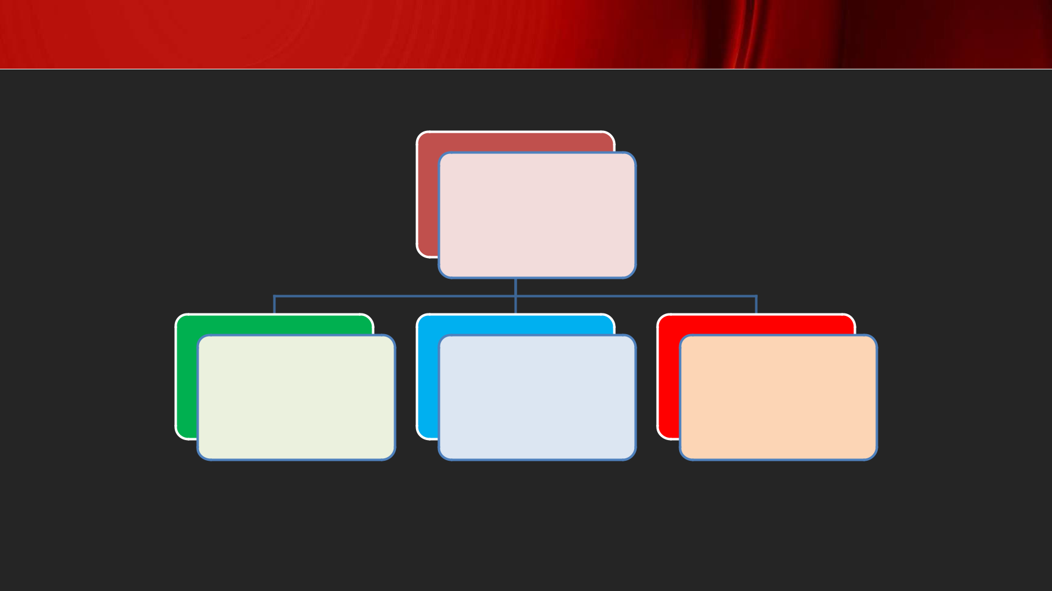Sitecore Security Domains

Domains

Default Extranet Sitecore

[**https://doc.sitecore.com/xp/en/developers/93/platform-administration-and-architecture/security-domains.html#:~:text=Sitecore%20is%20setup%20with%20Extranet,are%20set%20to%20default%5Canonymous.**](https://doc.sitecore.com/xp/en/developers/93/platform-administration-and-architecture/security-domains.html#:~:text=Sitecore%20is%20setup%20with%20Extranet,are%20set%20to%20default%5Canonymous.)

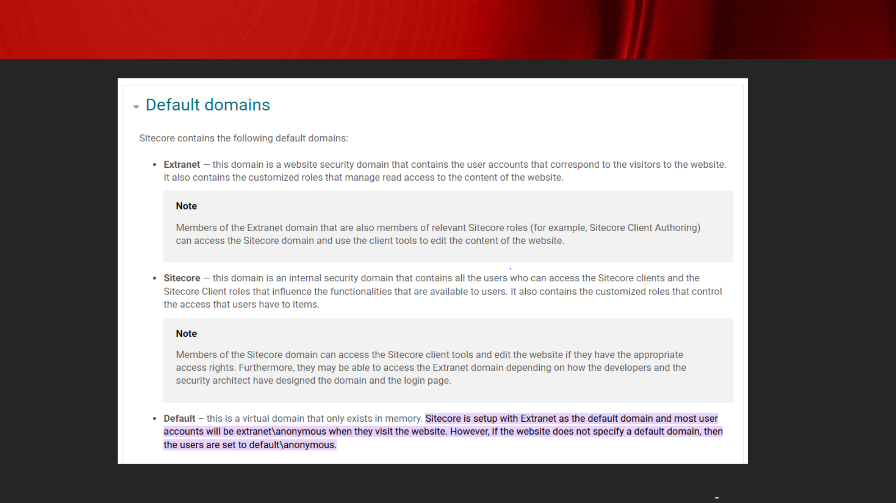

Sitecore Security Domains

[**https://doc.sitecore.com/xp/en/developers/93/platform-administration-and-architecture/security-domains.html#:~:text=Sitecore%20is%20setup%20with%20Extranet,are%20set%20to%20default%5Canonymous**](https://doc.sitecore.com/xp/en/developers/93/platform-administration-and-architecture/security-domains.html#:~:text=Sitecore%20is%20setup%20with%20Extranet,are%20set%20to%20default%5Canonymous)**.**

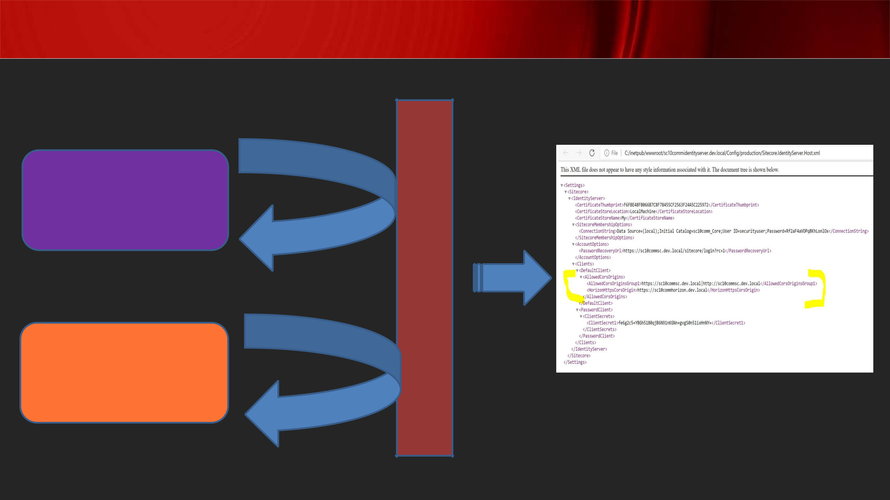Allowed CORS Origin

https://sc10commsc.dev.local

https://sc10commhorizon.dev.local

Authenticated

Authenticated

I

D

S

E

R

V

E

R

https://sc10identityserver.dev.local

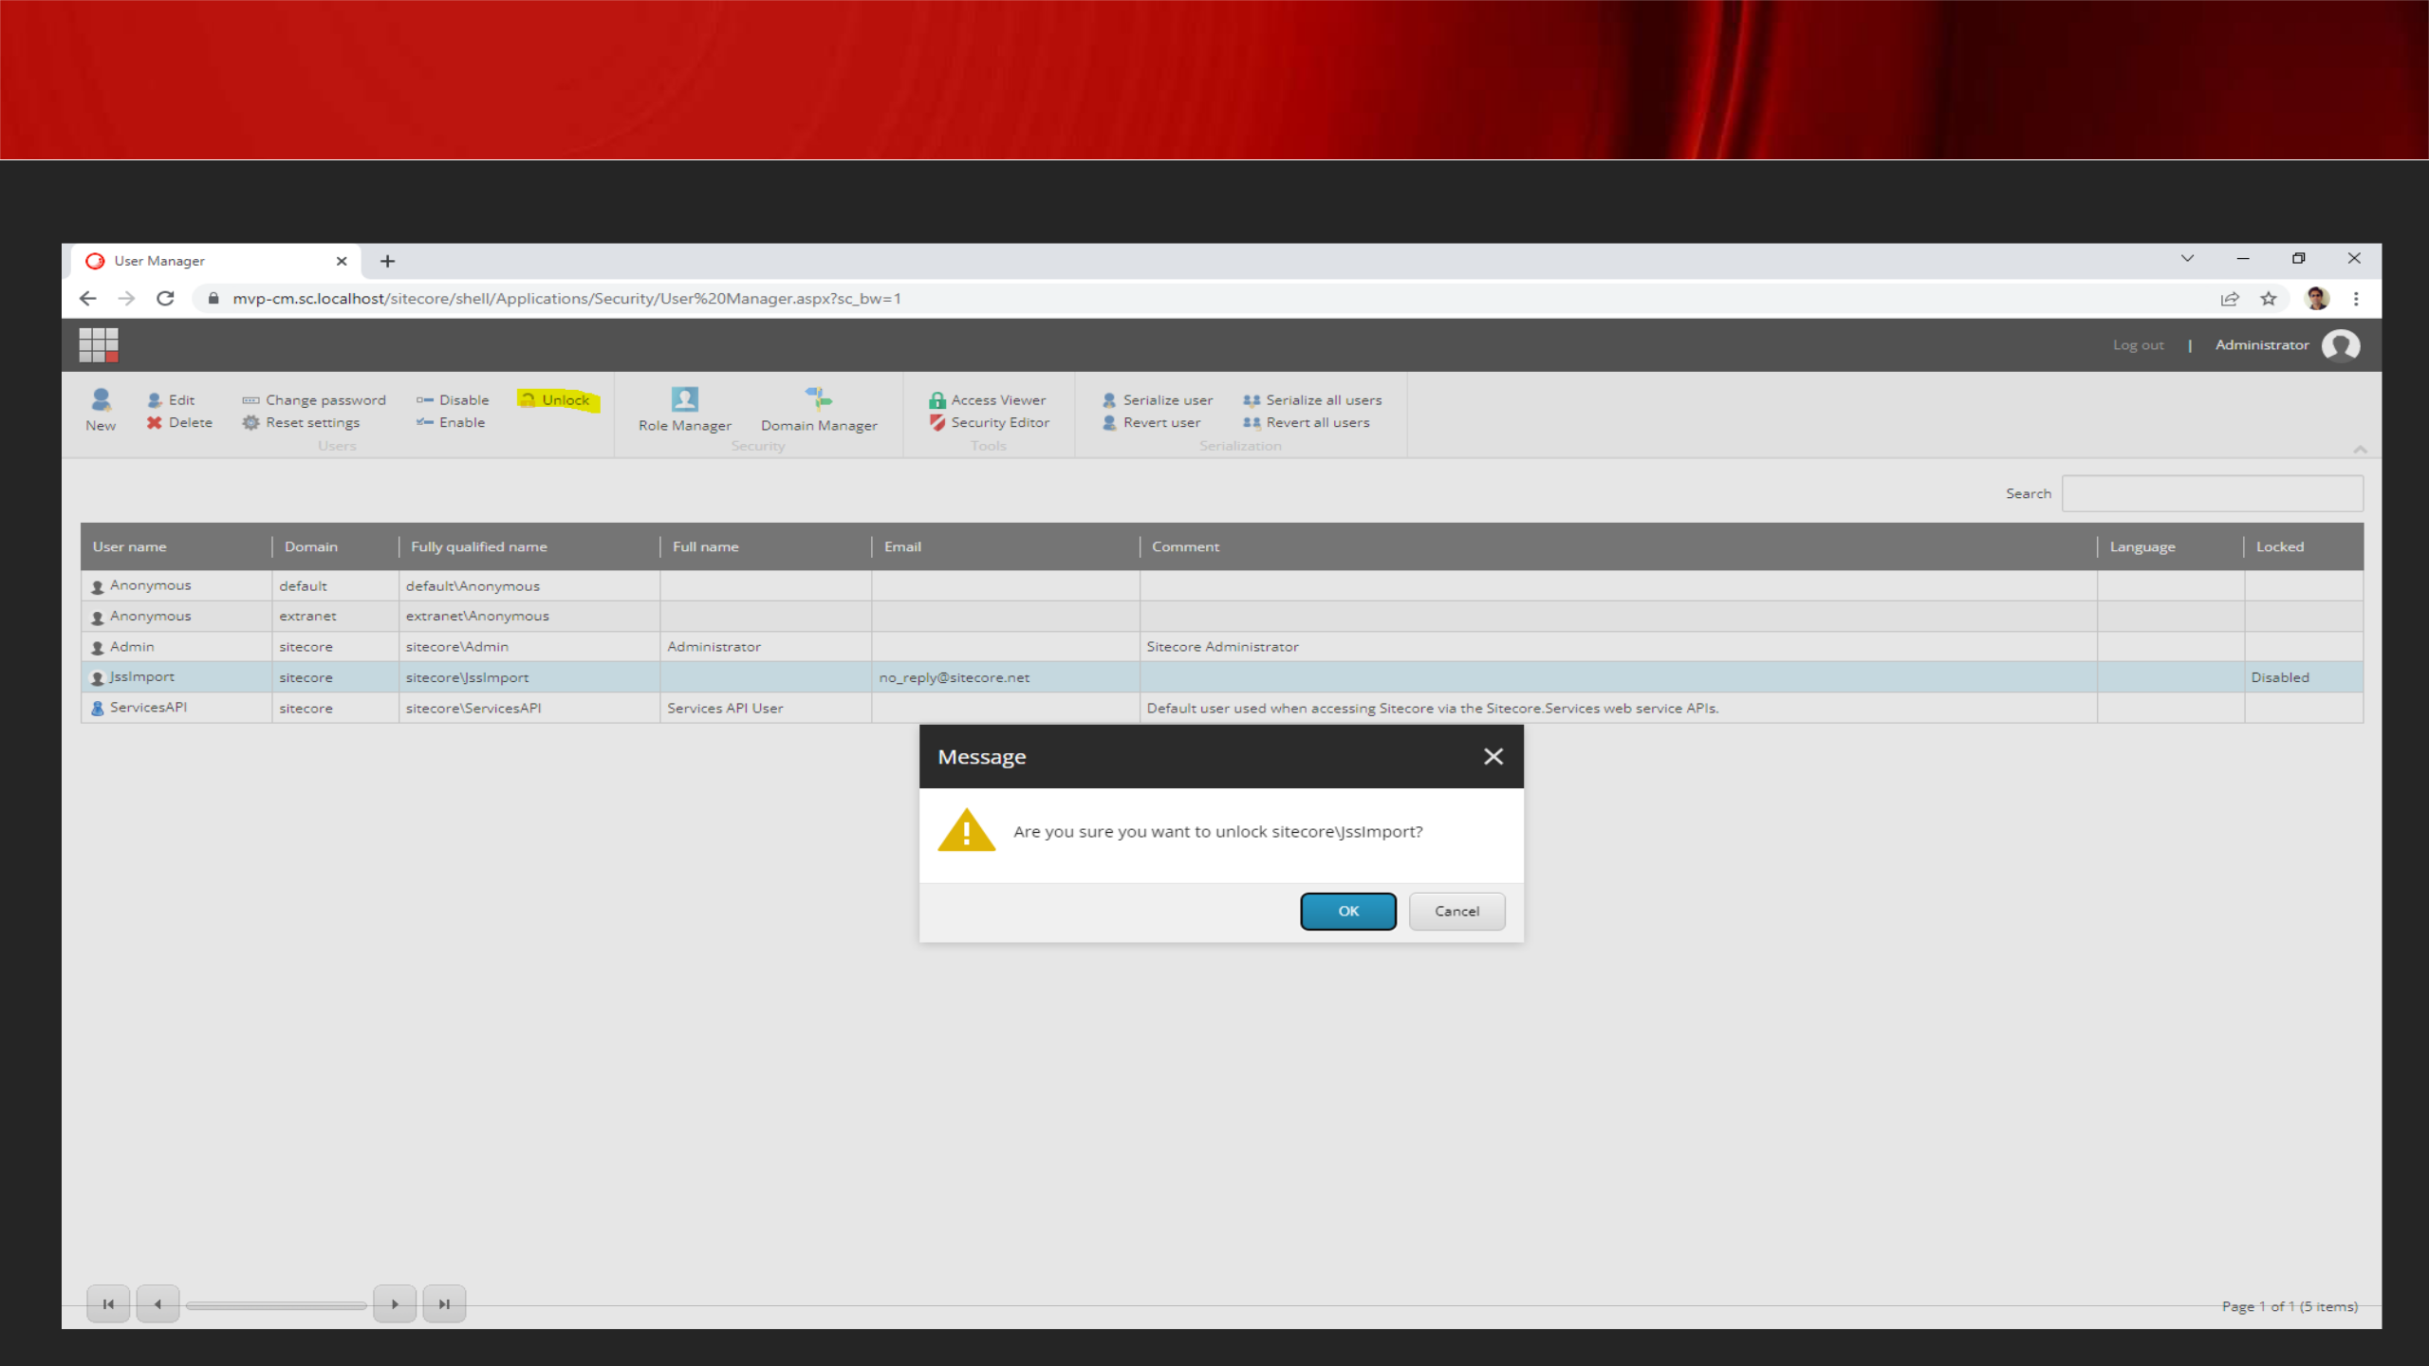User Manager

**Familiarise with user options below -**

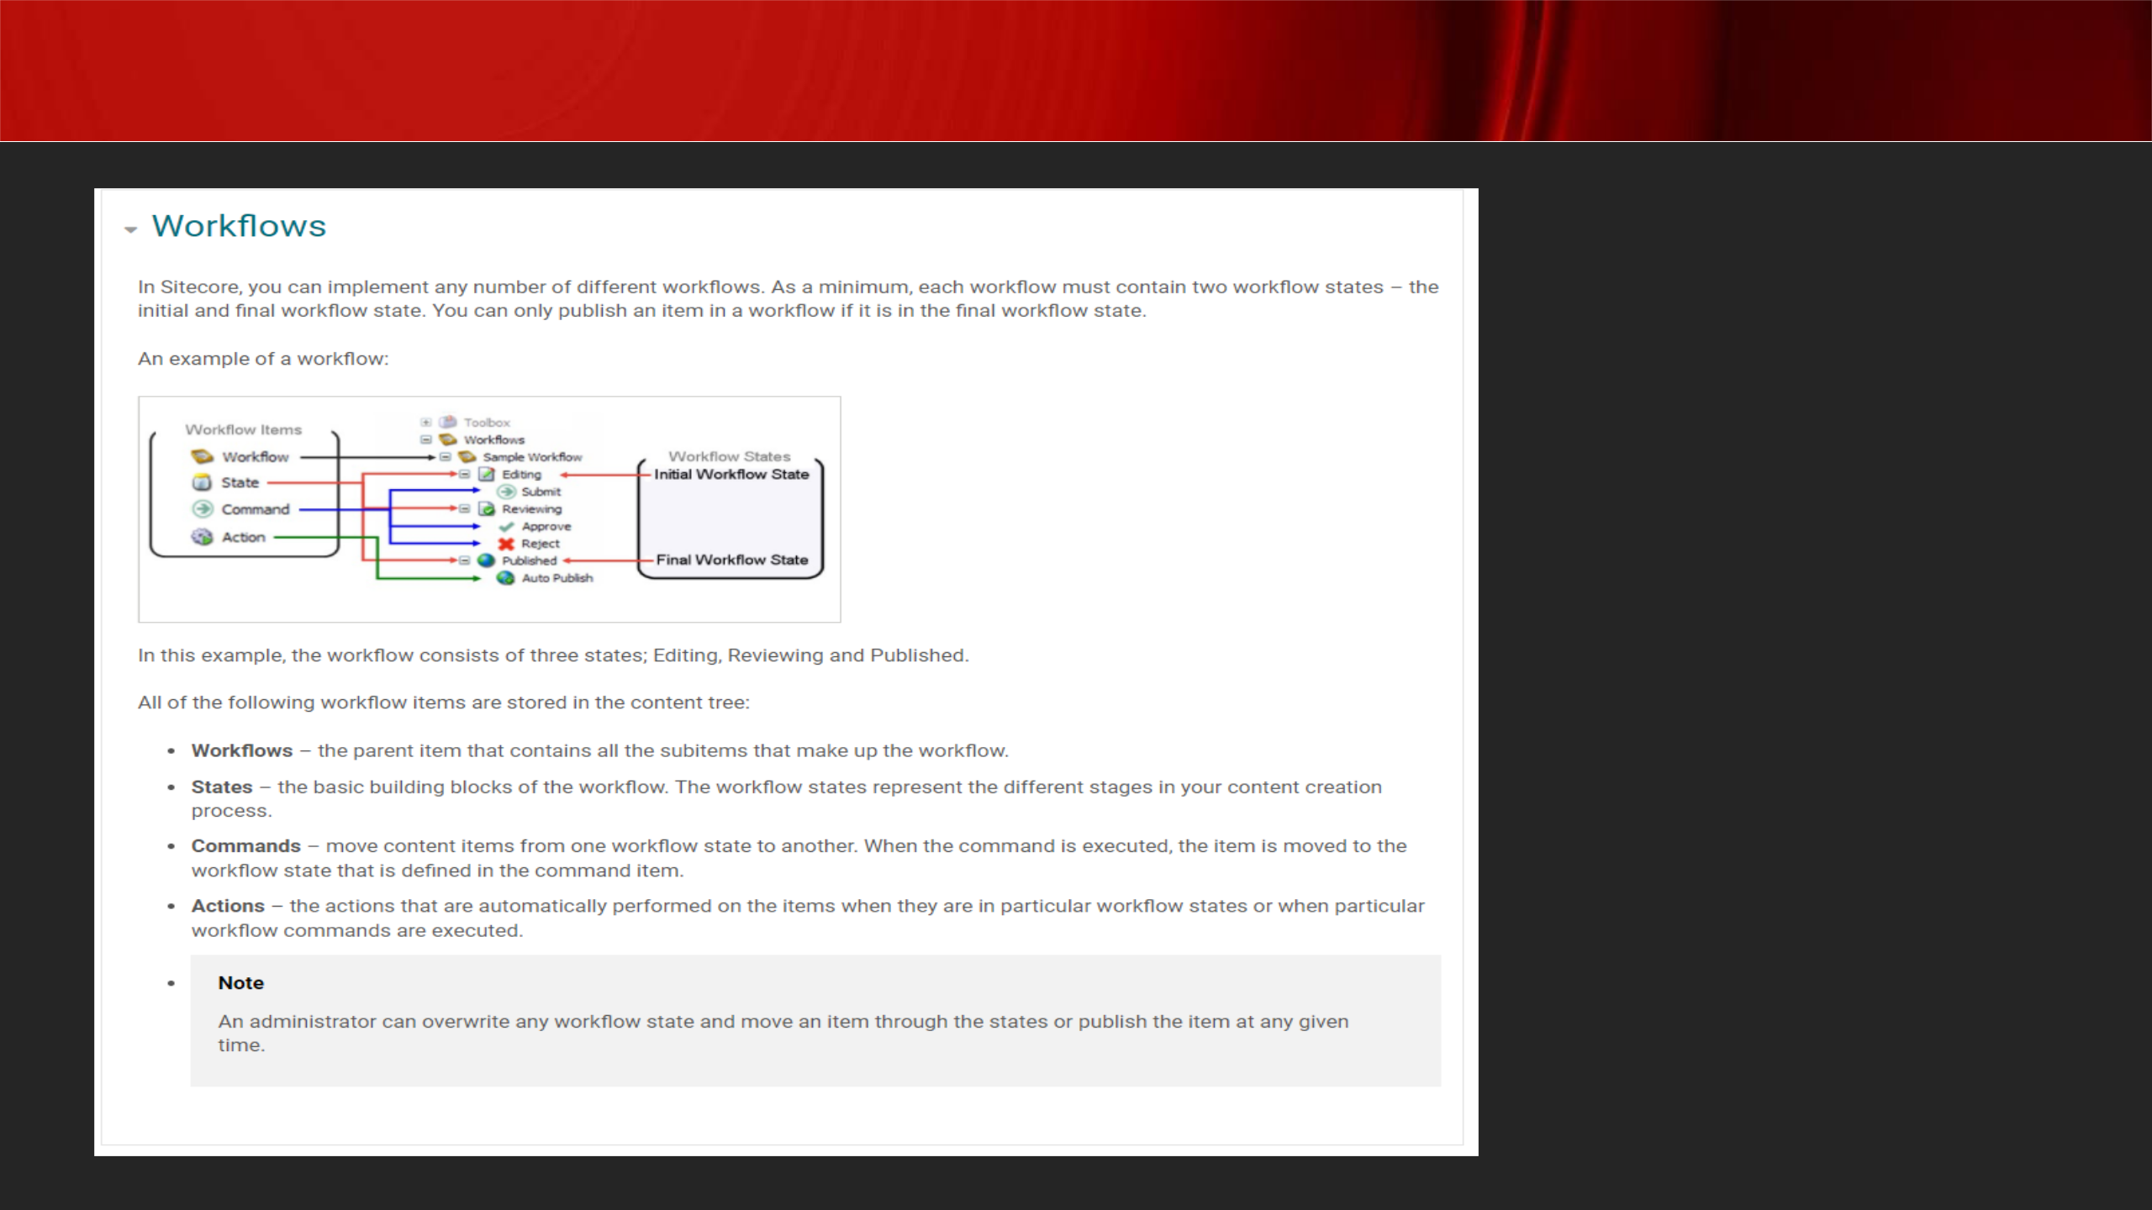Workflow

**Workflow Commands:**

**Content Editor Experience Editor Workbox**

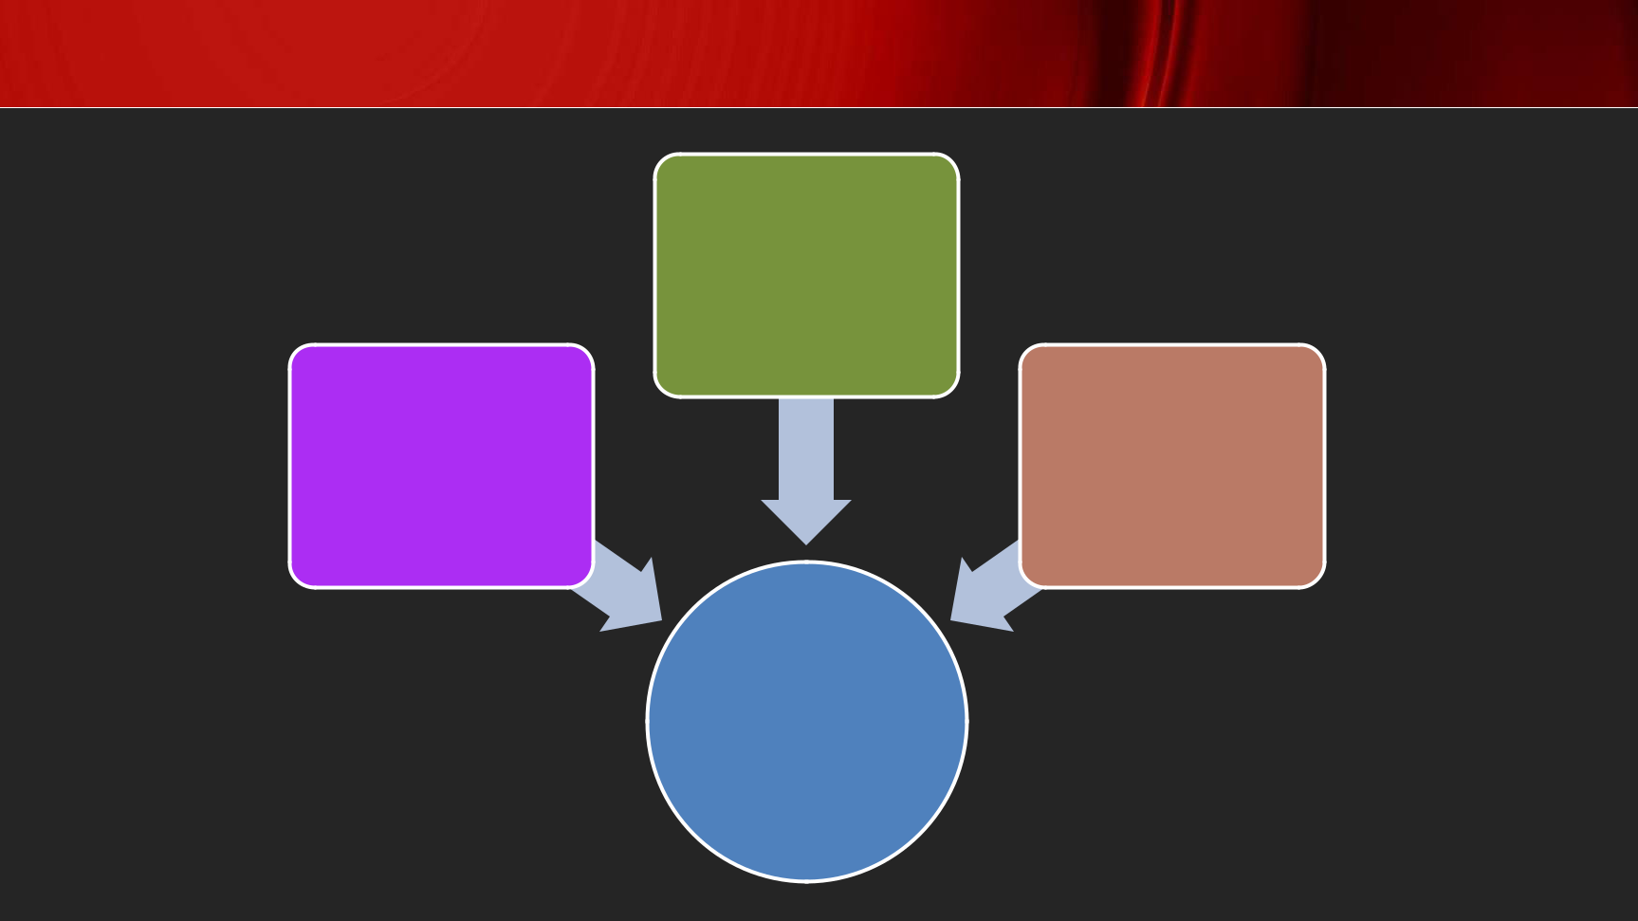Elements of a Workflow

Commands

States Actions

Workflow

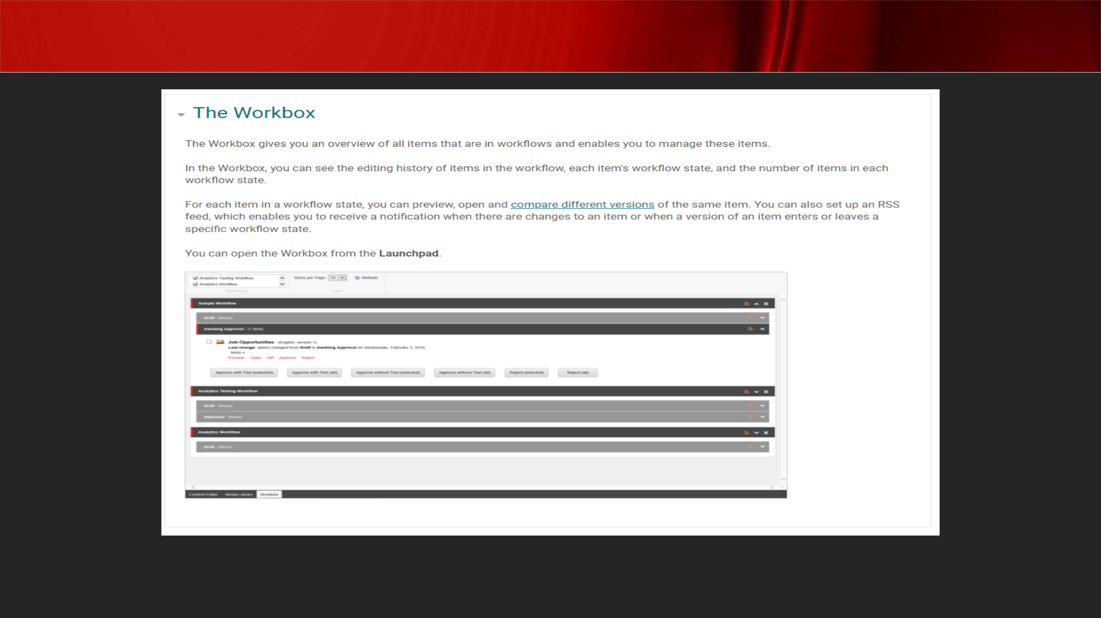

Sitecore Workbox

[**https://doc.sitecore.com/xp/en/users/93/sitecore-experience-platform/workflows-and-the-workbox.html**](https://doc.sitecore.com/xp/en/users/93/sitecore-experience-platform/workflows-and-the-workbox.html)

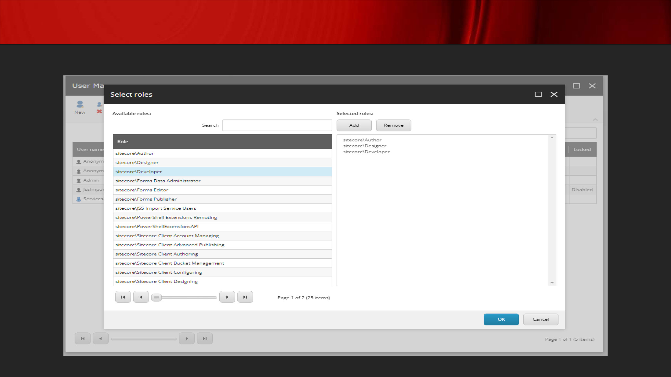Users/Groups - Security

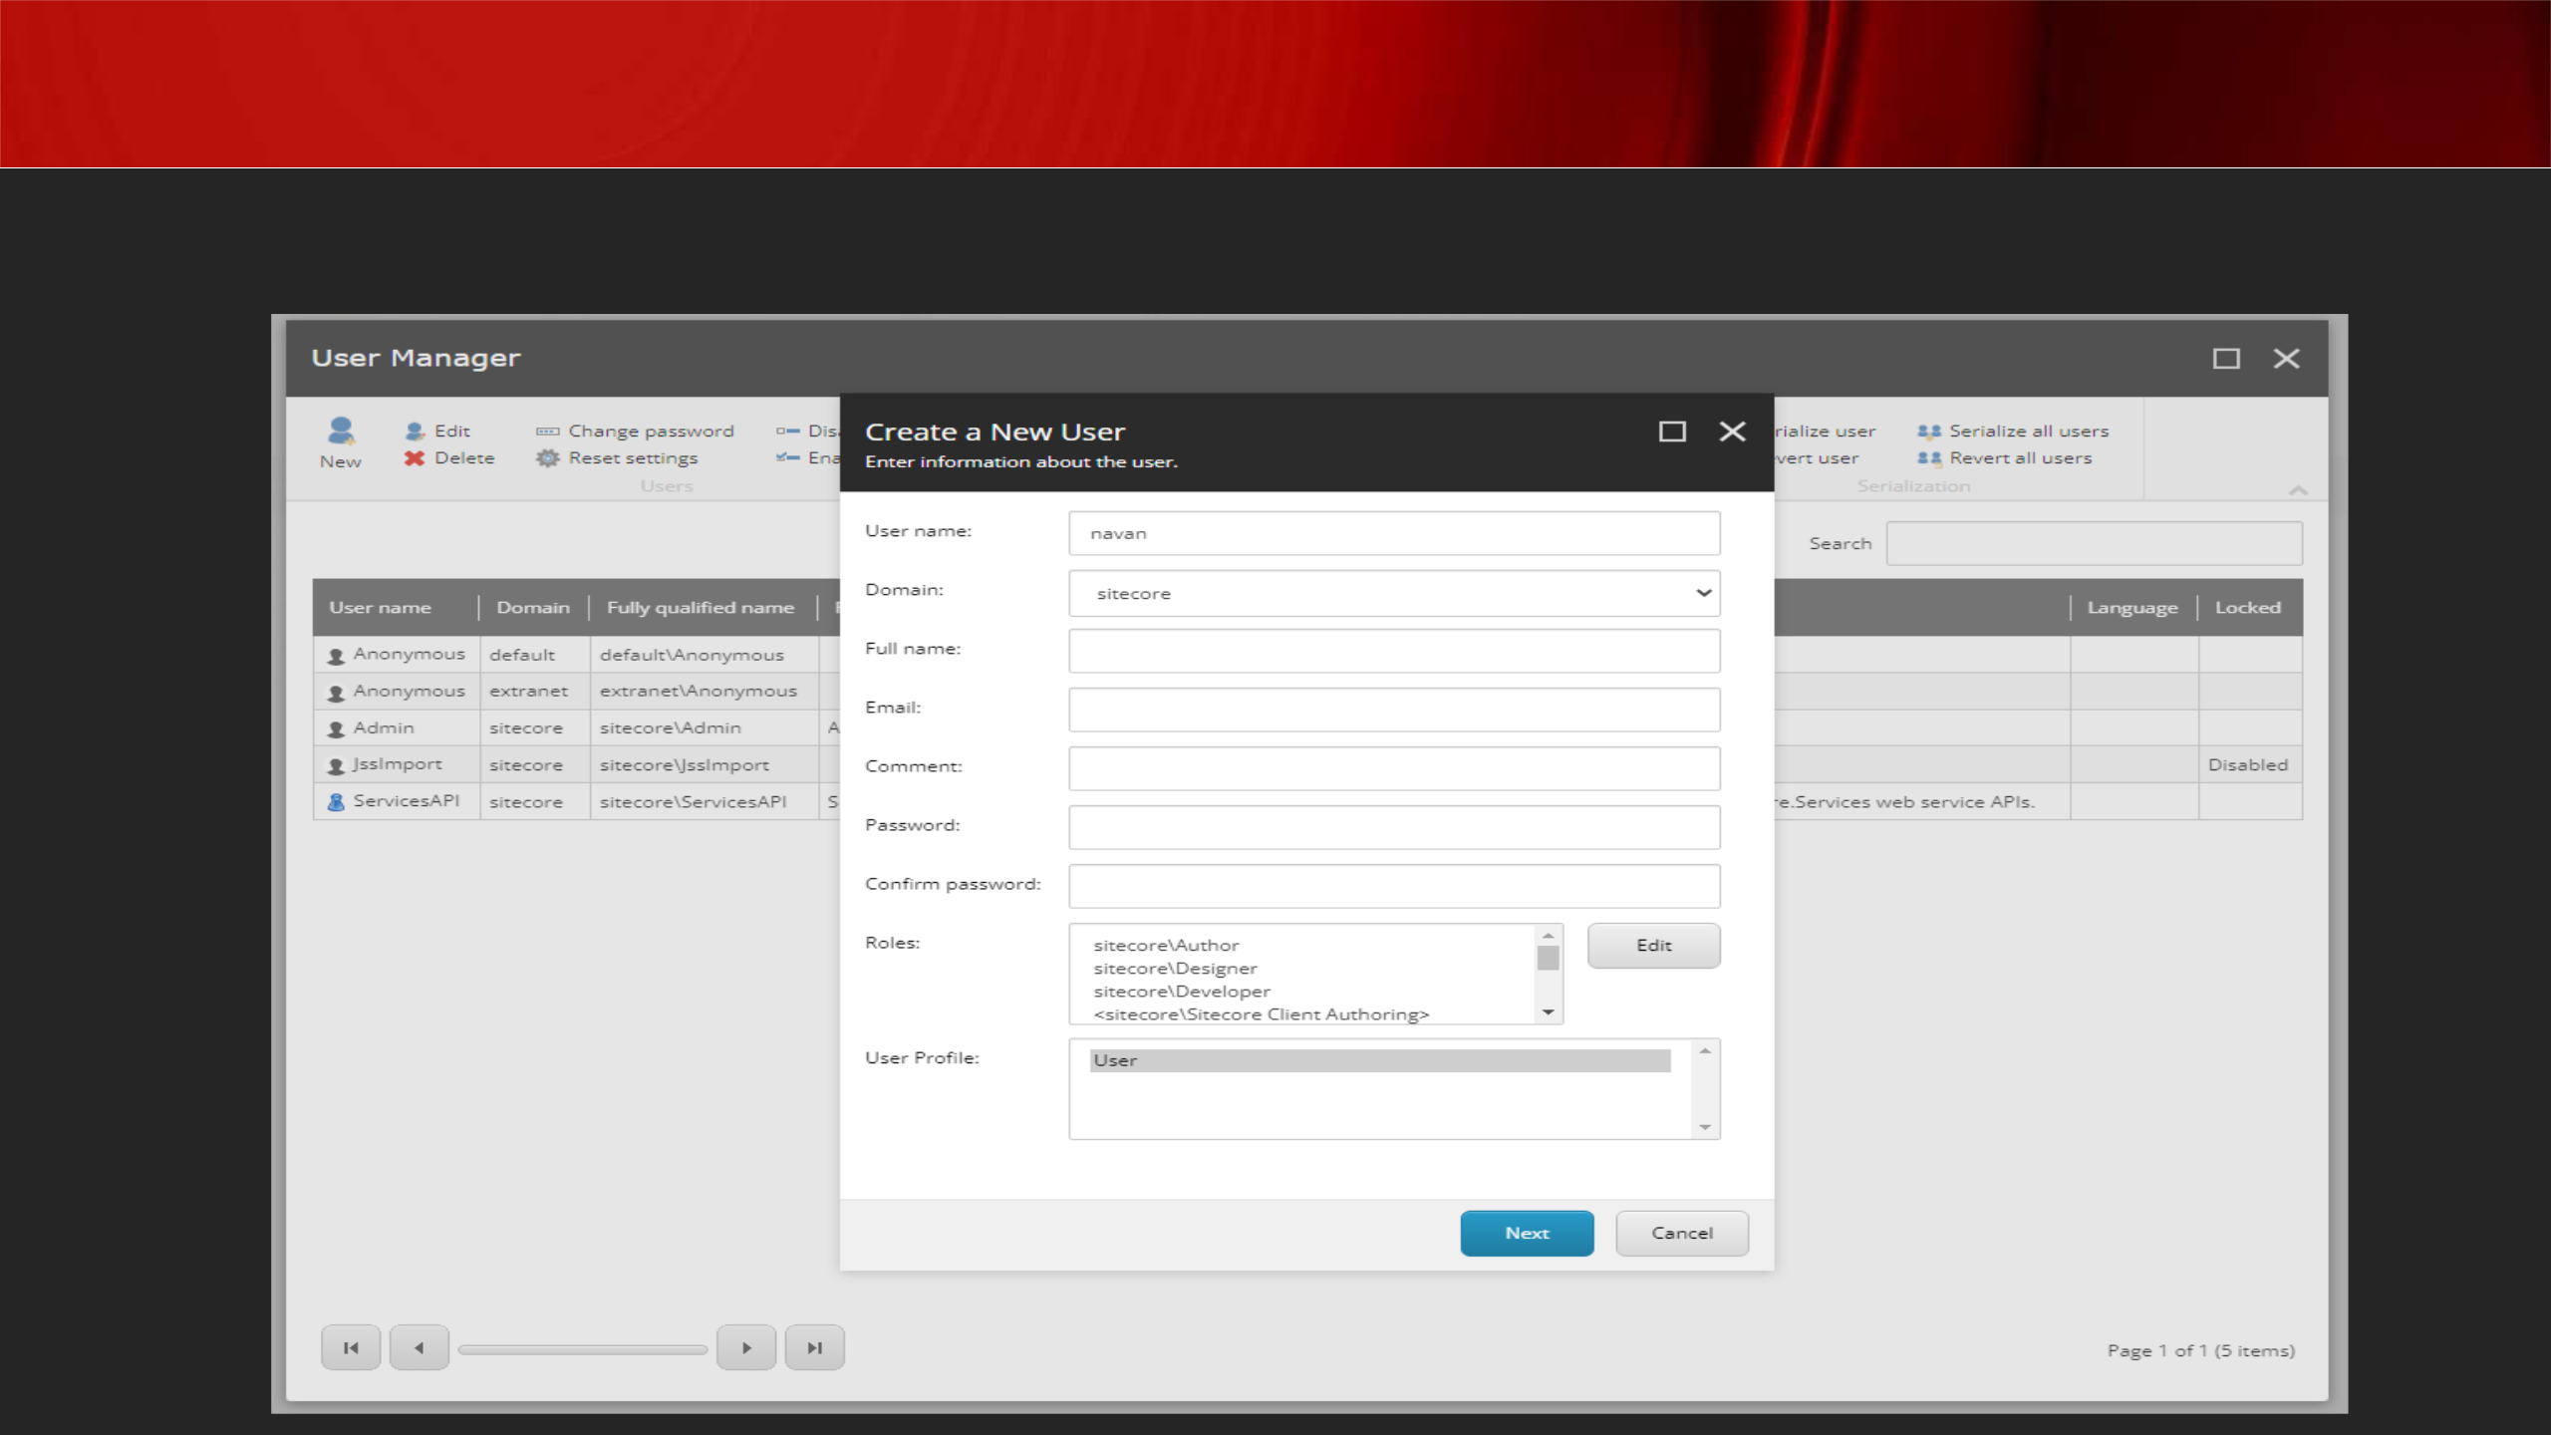Users/Groups - Security

**Can edit roles for a user**

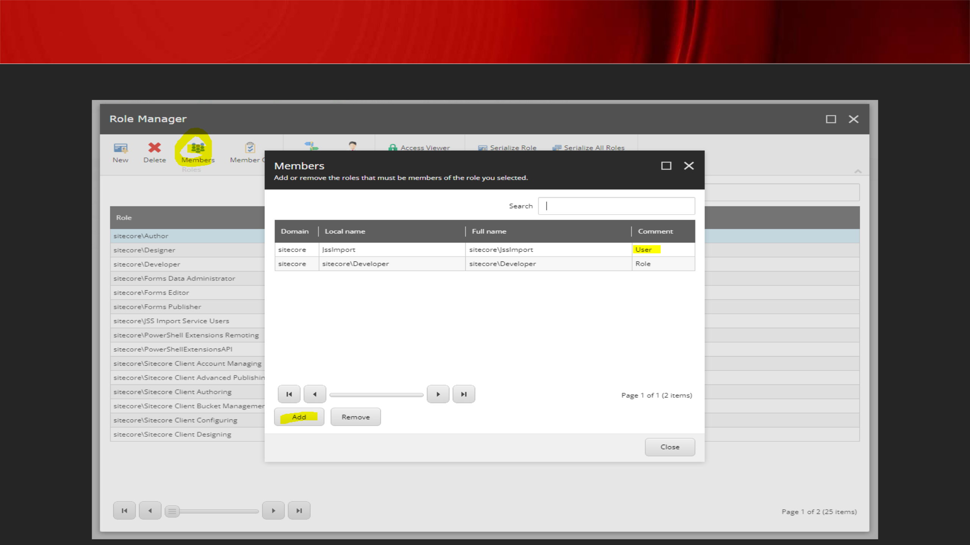Role Manager

**Can add users as members of a role**

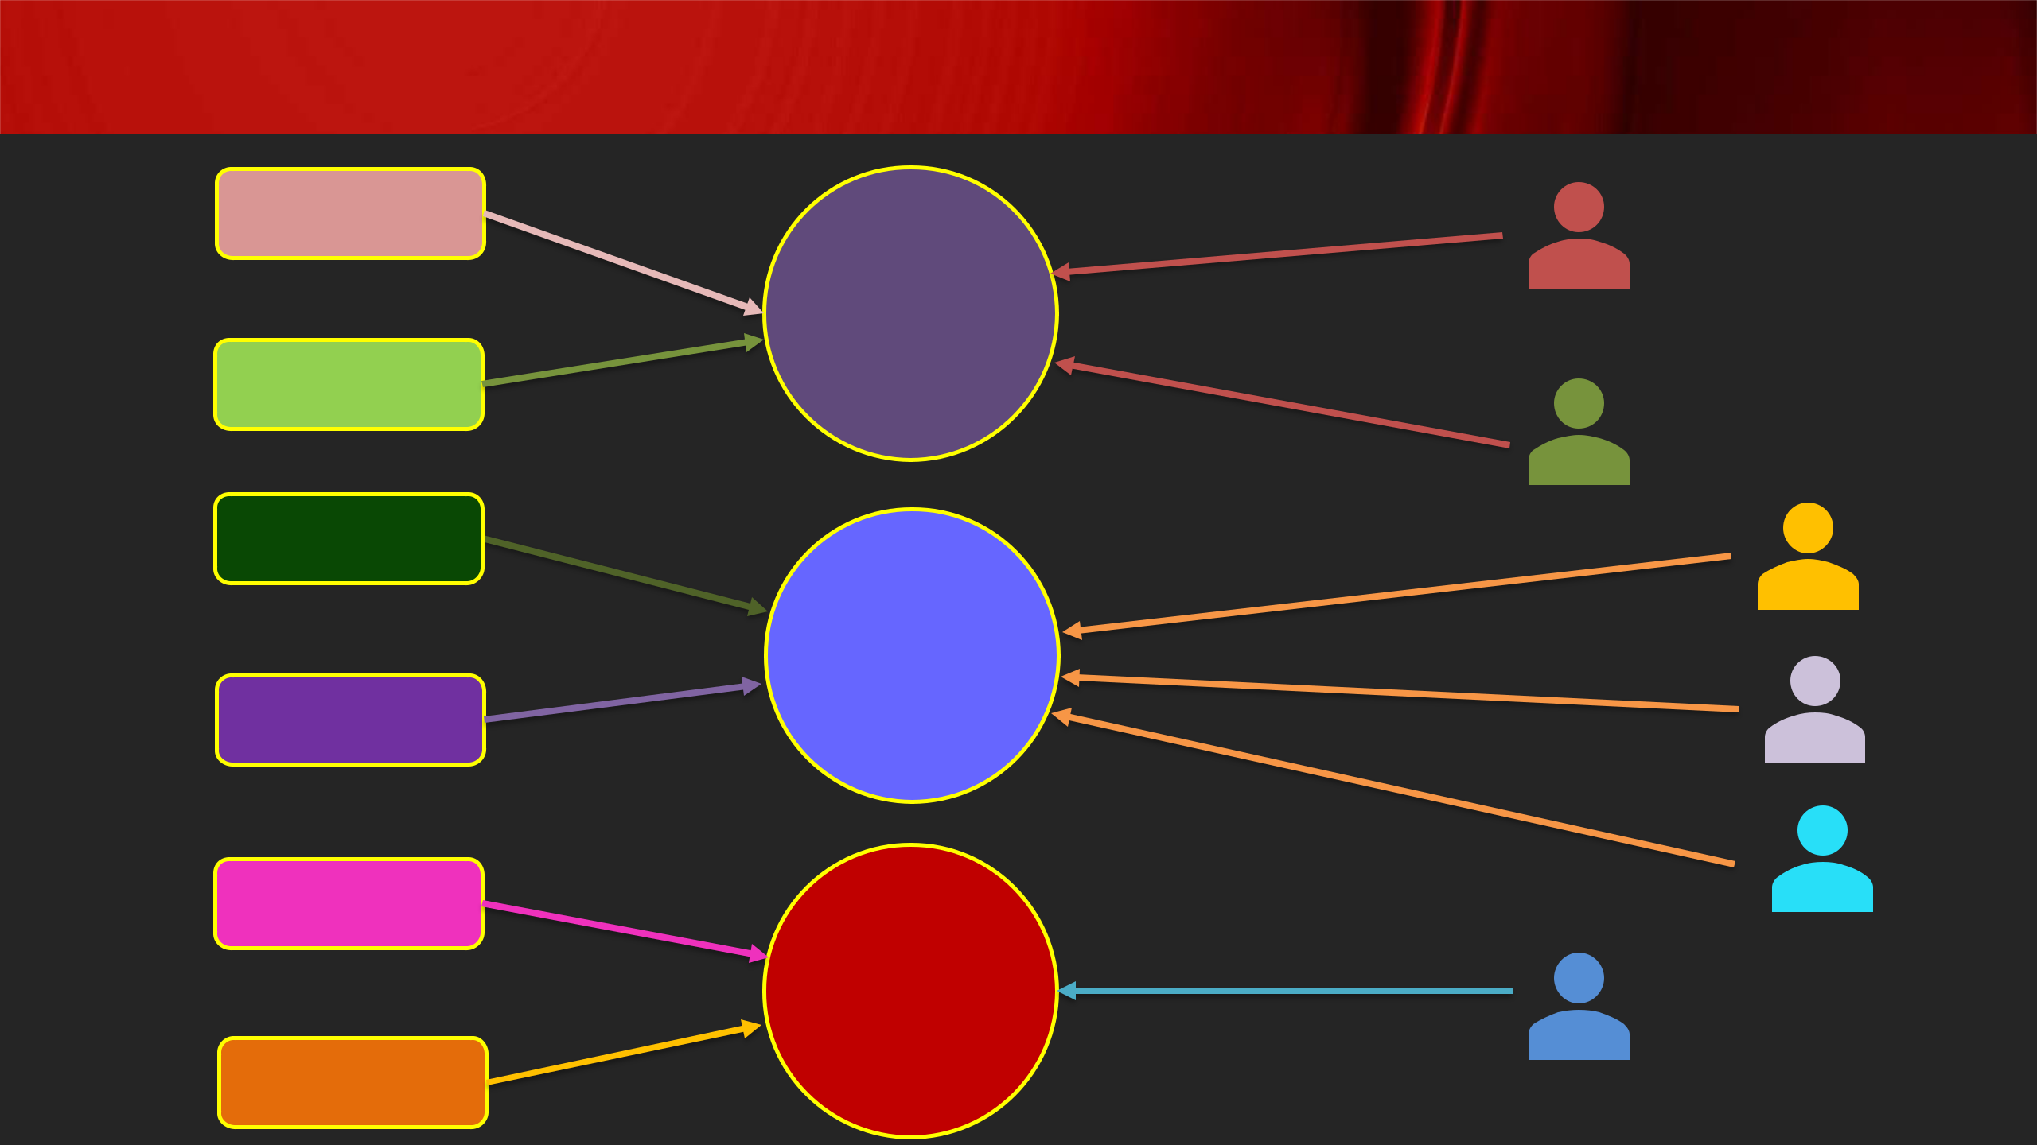Users/Groups - Security

Permission-1

Role-1

Permission-2

Permission-3

Role-2

Permission-4

Permission-5

Role-3

Permission-6

**Members**

**Members**

**Members**

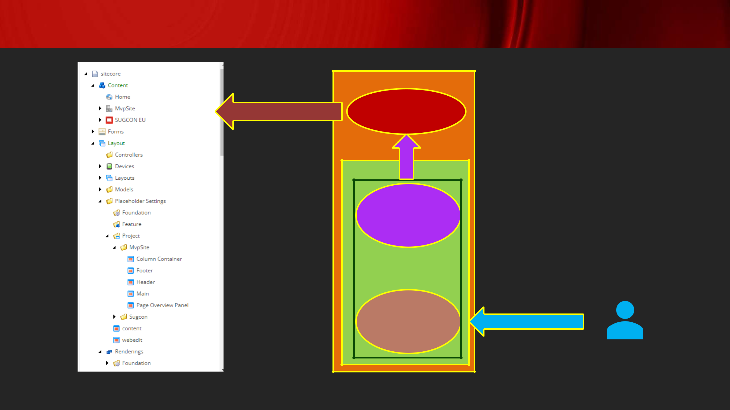Sitecore ASP.NET Core Rendering Host

|  |  |  |
| --- | --- | --- |
|  | Headless |  |
|  | Services |  |
| R |  |  |
| E |  |  |
| N | Layout |  |
| D | Service |  |
| E | Client |  |
| R |  |
| ASP.NET Core |  |
| I |  |
| N | Rendering SDK |  |
| G |  |  |
| H | Rendering |  |
| O | Engine |  |
| S |  |  |
| T |  |  |
| **CM** | **CD** |  |

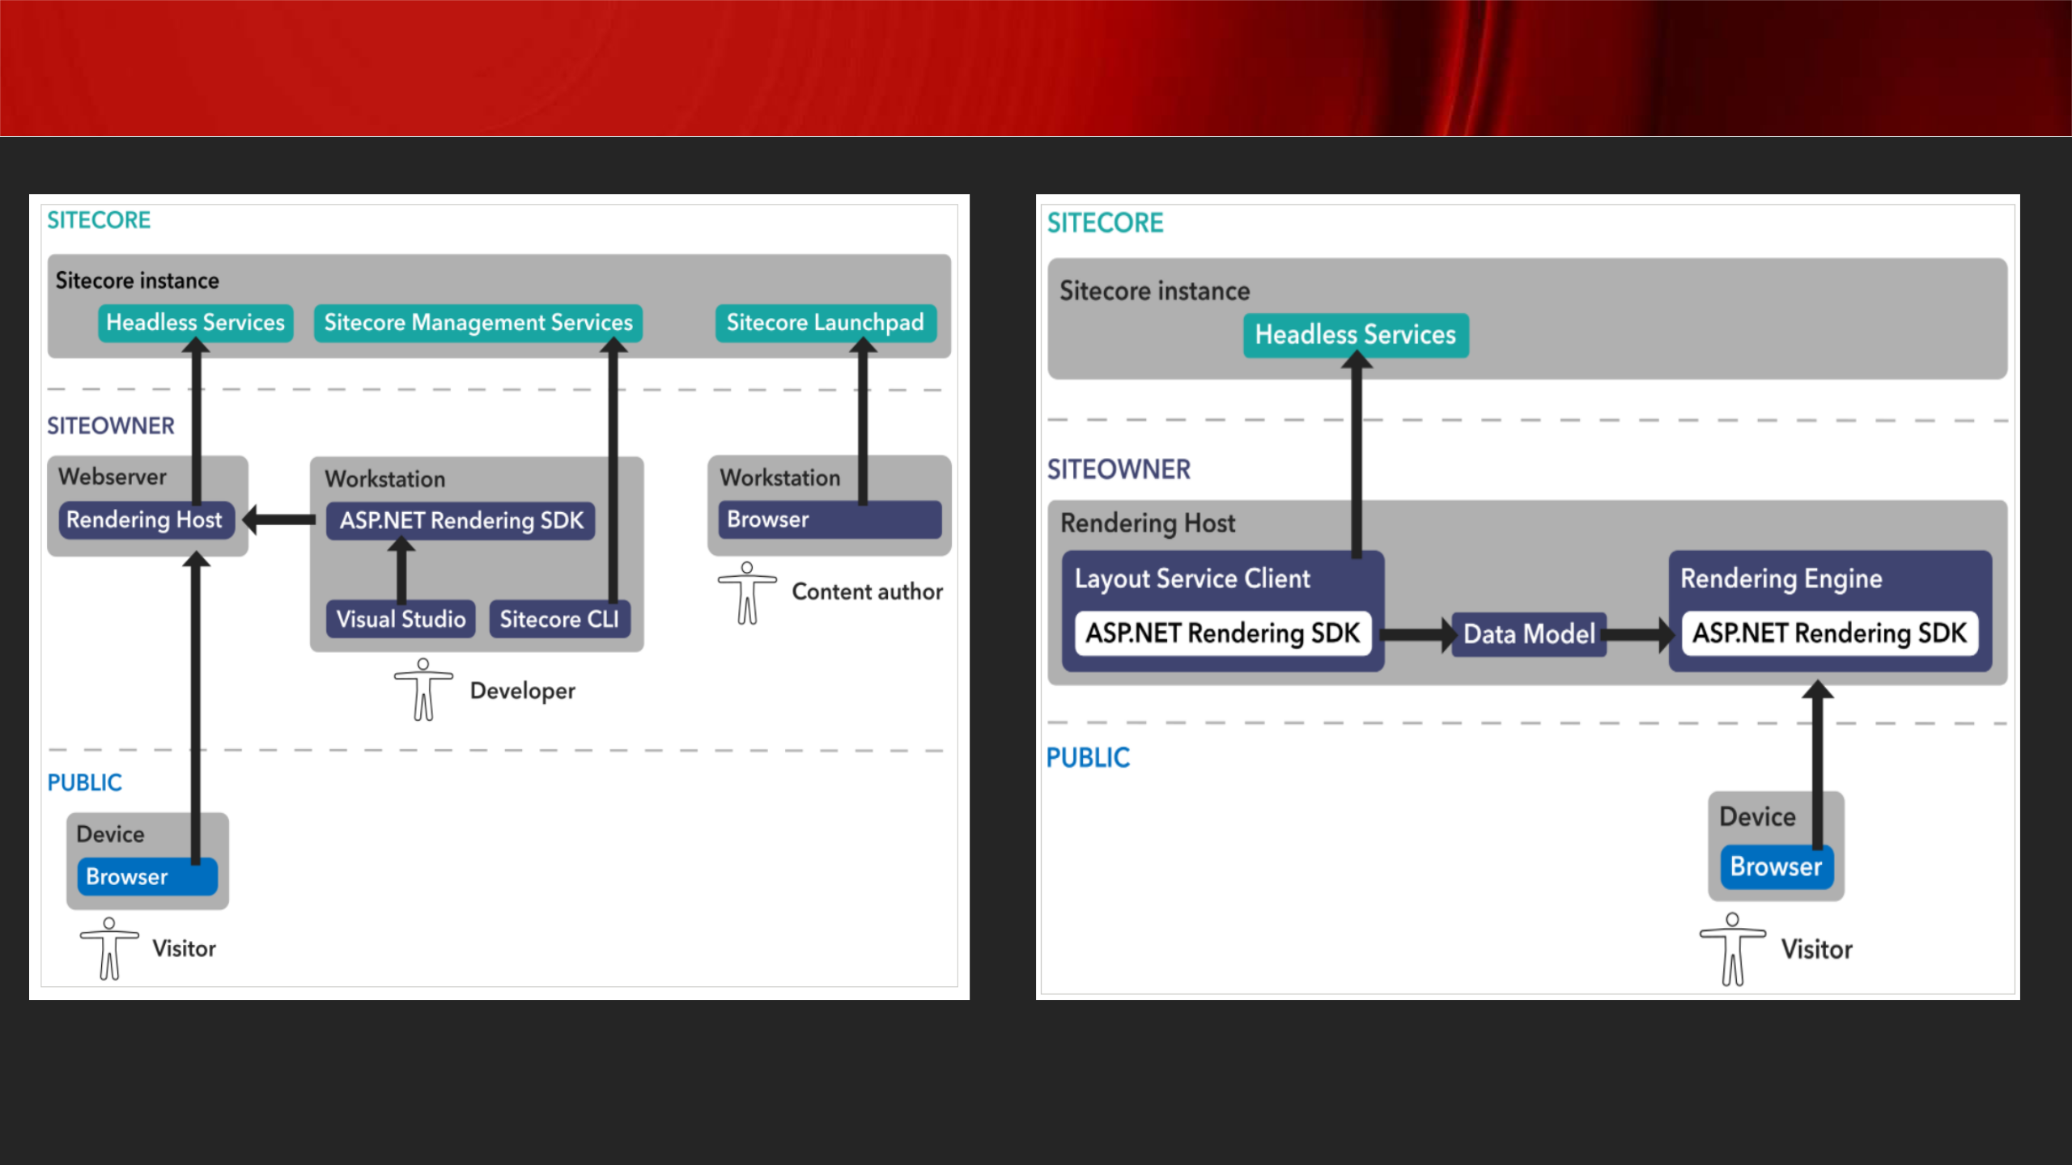

Sitecore Headless Service

[**https://doc.sitecore.com/xp/en/developers/100/developer-tools/sitecore-headless-development-conceptual-overview.html**](https://doc.sitecore.com/xp/en/developers/100/developer-tools/sitecore-headless-development-conceptual-overview.html)



Sitecore ASP.NET Core Application Layers

|  |  |  |  |  |  |
| --- | --- | --- | --- | --- | --- |
|  | **Shared** |  | - | **Shared Model** |  |
|  |  |  |
|  |  |  |  |  |
|  | **(.Net Standard)** |  | - | **Any shared logic** |  |
|  |  |  |  |  |  |
|  |  |  | - | **Sitecore Pipeline Processor** |  |
|  |  |  | - **Sitecore Layout Service Resolver** | |  |
|  | **Platform** |  | - | **Any kind of patching logic** |  |
|  | **(.NET 4.8)** |  | - | **Schema Extender** |  |
|  |  |  |  |
|  |  |  | - **Service / Application Logic** | |  |
|  |  |  | - **References Sitecore Layout Service** | |  |
|  |  |  |  | |  |
|  |  |  | - **Controller logic means APIs can be exposed** | |  |
|  | **Rendering** |  | - **References other .NET core projects** | |  |
|  |  | - **As the name goes, views fall here** | |  |
|  | **(.Net Core App)** |  |  |
|  |  | - **References Sitecore Layout Service Client** | |  |
|  |  |  |  |
|  |  |  | - **Cross-cutting calls must be through APIs as per headless principles** | |  |
|  |  |  |  |  |  |

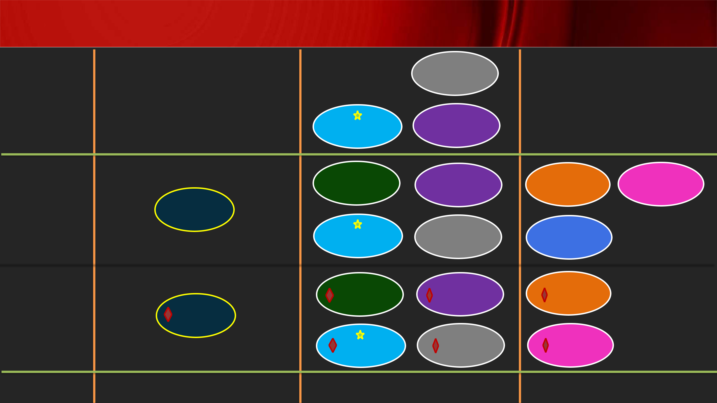

Sitecore ASP.NET Core Application Design

|  |  |  |
| --- | --- | --- |
| **Shared** | Social |  |
| **(.Net** |  |  |
| **Standard)** | BasicContent |  |
| Forms |  |

|  |  |  |  |
| --- | --- | --- | --- |
| Navigation | BasicContent | People | User |

**Platform**

|  |  |  |
| --- | --- | --- |
| **(.NET 4.8)** | MVP Site |  |
|  |  |

|  |  |  |  |
| --- | --- | --- | --- |
| Forms | Social | Sitecore |  |
| Extensions |  |
|  |  |  |

|  |  |  |  |  |
| --- | --- | --- | --- | --- |
| **Rendering** | Navigation | BasicContent | People |  |
|  |  |
| **(.Net Core** | MVP Site |  |  |  |
| **App)** | Forms | Social | User |  |
|  |  |
|  | **Project** | **Feature** | **Foundation** |  |

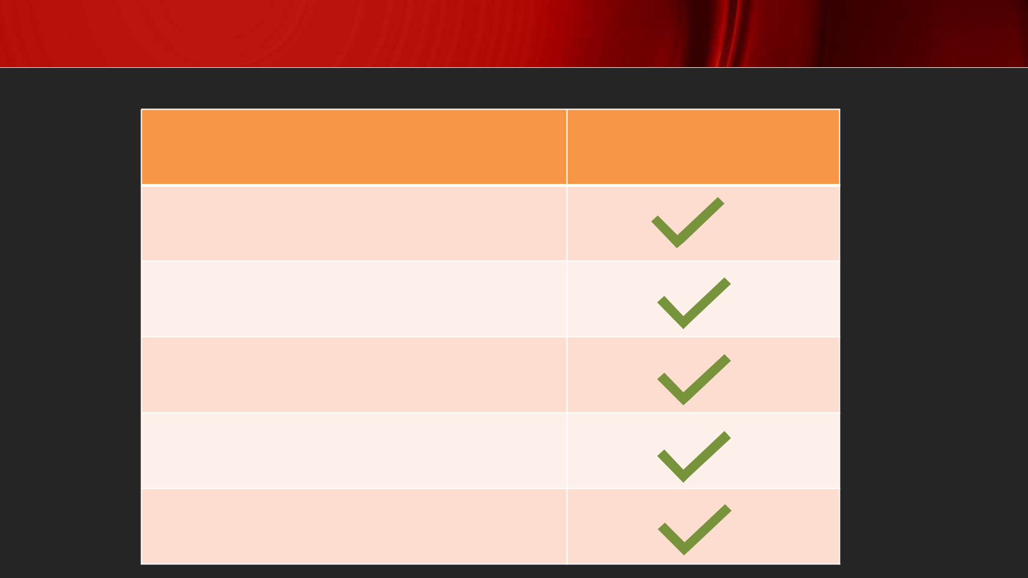Sitecore ASP.NET Core Application Features

**Feature**

Independent, render Sitecore Content

De-coupled

Light-weight

Consumes Sitecore Layout Service

Preview Code Changes

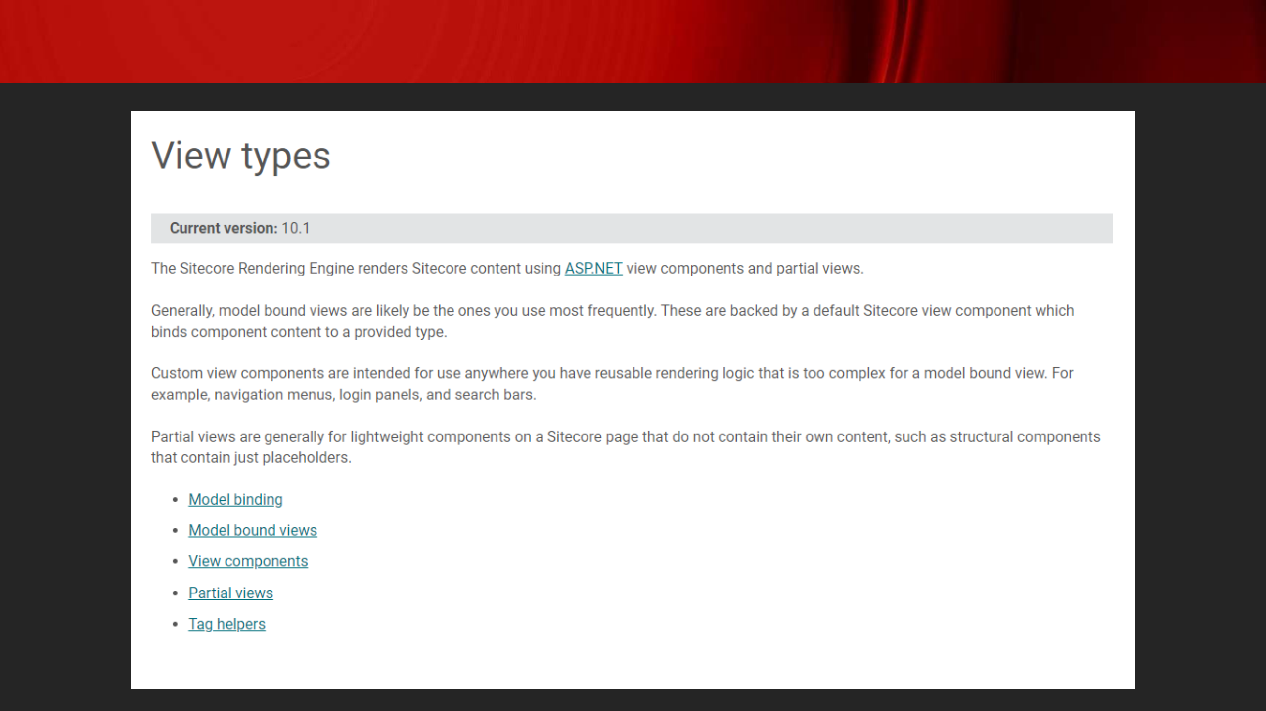Sitecore ASP.NET Rendering SDK

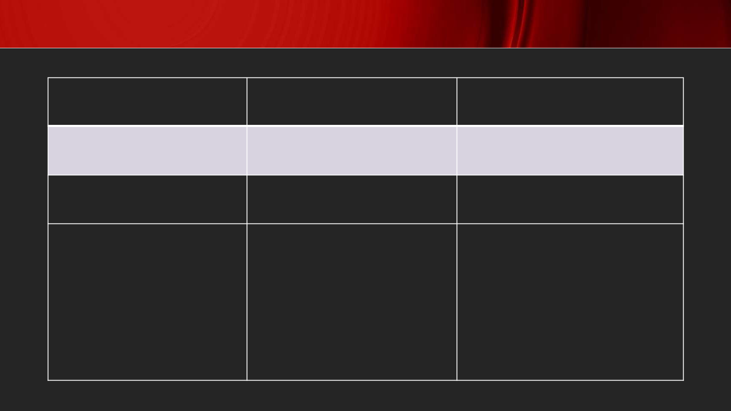Sitecore ASP.NET Rendering View Types

|  |  |  |
| --- | --- | --- |
| **Model-bound View** | **Custom View** | **Partial View** |
|  |  |  |

|  |  |  |
| --- | --- | --- |
| Most-commonly used | Reusable | Structural |

|  |  |  |
| --- | --- | --- |
| View backed by a model | Complex logic | Light-weight |
|  |  |  |

|  |  |  |
| --- | --- | --- |
| • | Navigation menus | Placeholders |
| • | Login panels |  |
| • | Search bar |  |
|  |  |  |

Startup.cs Functionality

* **Register the Sitecore Layout Service Client invoked by the Sitecore Rendering Engine.**
* **Register the Sitecore Rendering Engine services.**
* **Map a Sitecore rendering component name to an implementation**
* **Forwarding of Scheme as X-Forwarded-Proto to the Layout Service**
* **Enable support for the Experience Editor**
* **Standard ASP.NET Core routing and static file support**

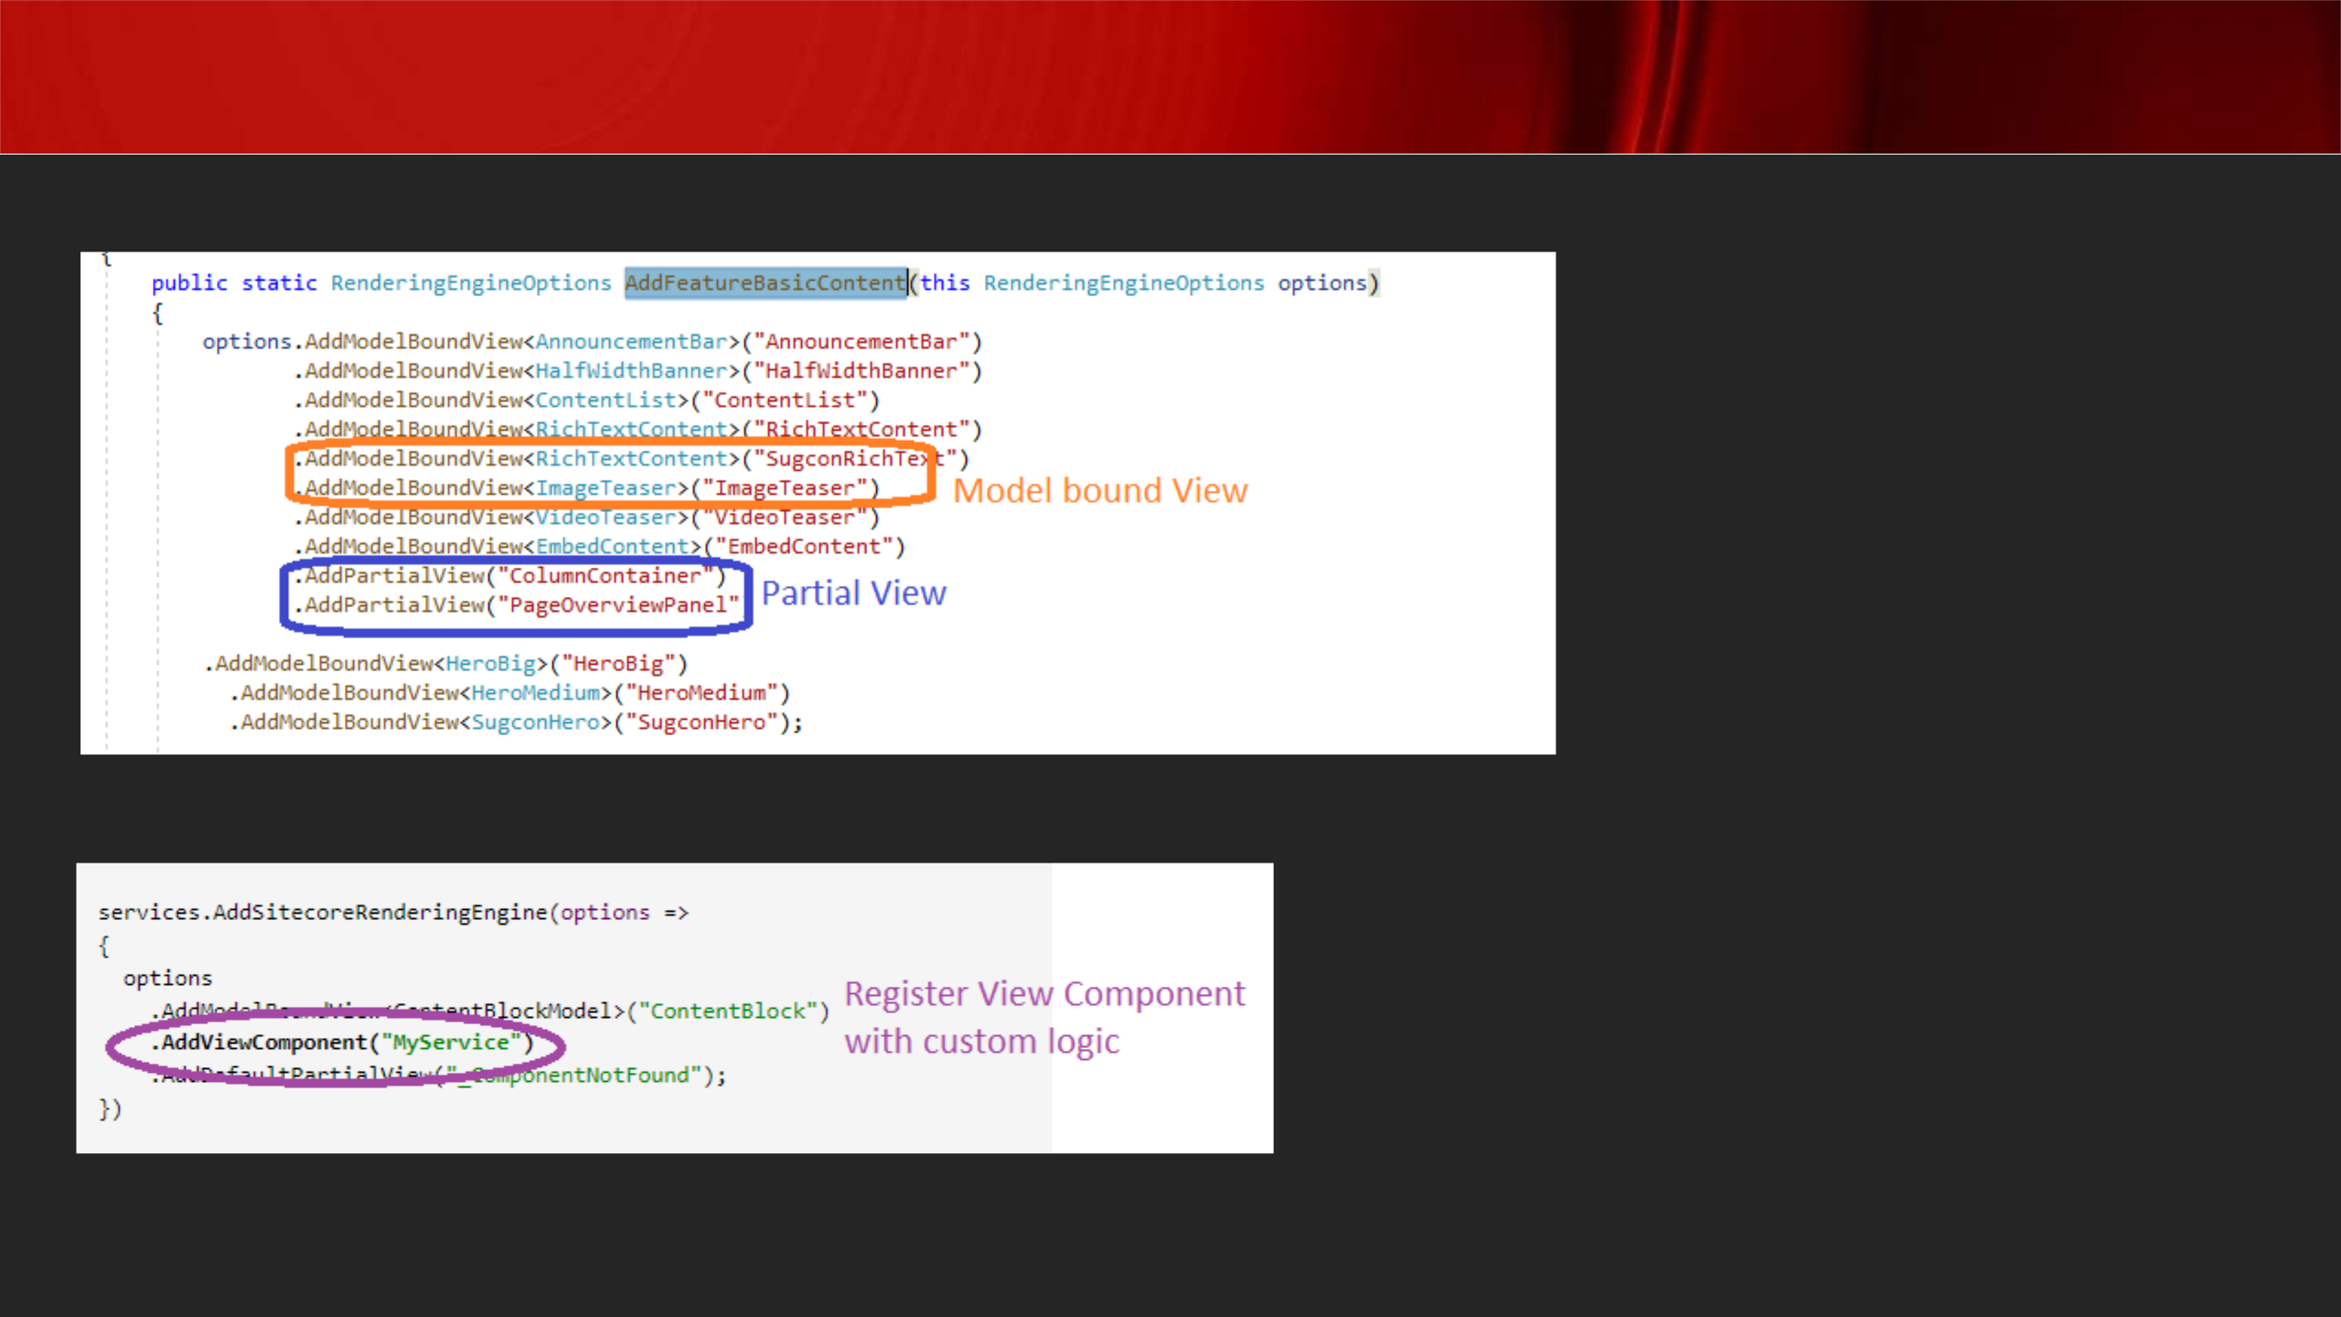

Service registration in Startup.cs

**Model-bound View and Partial View Component:**

**Custom View Component:**

[**https://doc.sitecore.com/xp/en/developers/100/developer-tools/walkthrough--**](https://doc.sitecore.com/xp/en/developers/100/developer-tools/walkthrough--creating-a-view-component-with-custom-logic.html)[**creating-a-view-component-with-custom-logic.html**](https://doc.sitecore.com/xp/en/developers/100/developer-tools/walkthrough--creating-a-view-component-with-custom-logic.html)

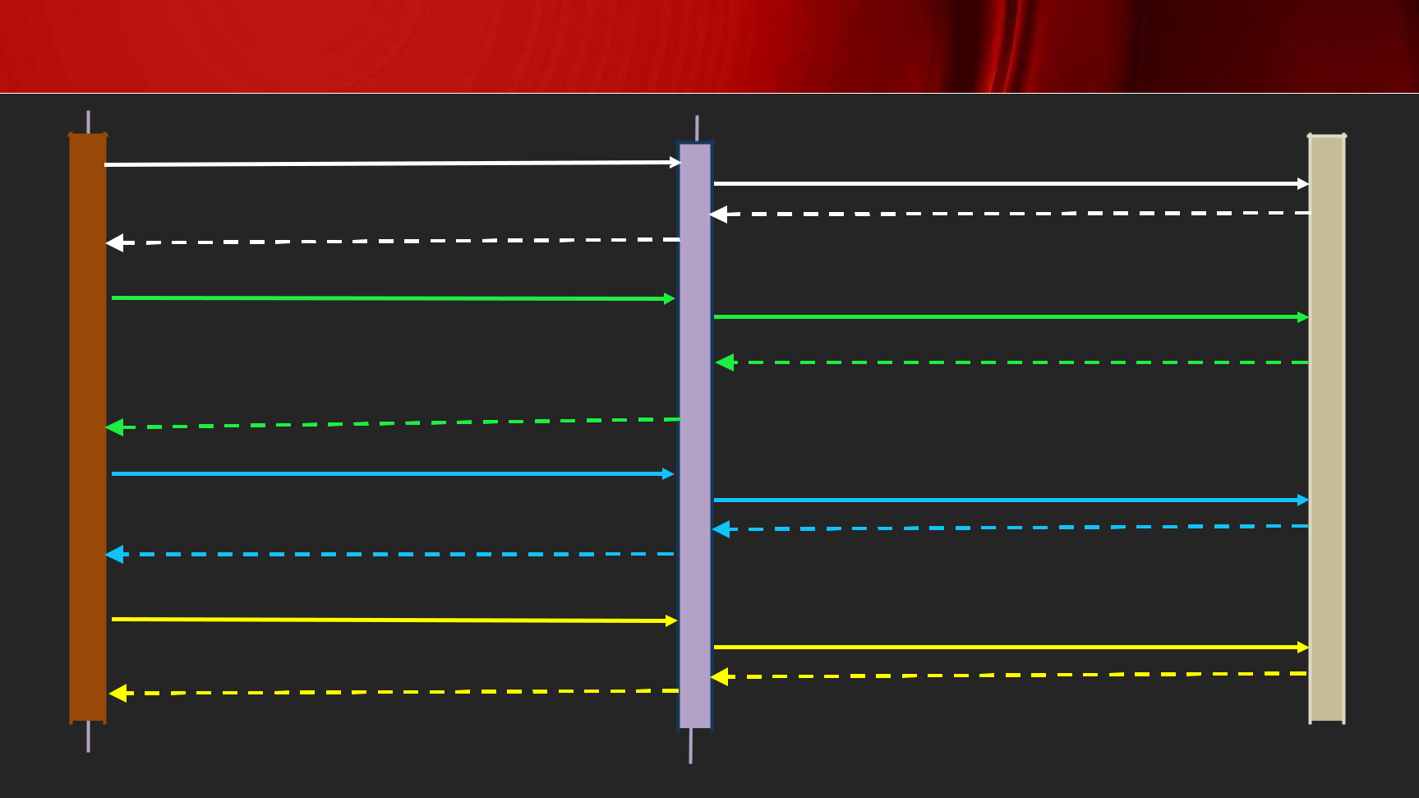

Sitecore CLI Plugin Setup

Dotnet new tool-manifest

Create .config\dotnet-tools.json

Dotnet local tool manifest file created

|  |  |  |
| --- | --- | --- |
| dotnet tool install Sitecore.CLI --add-source | Update CLI version in .config\dotnet-tools.json |  |
| https://sitecore.myget.org/F/sc- |  |
|  |  |
| packages/api/v3/index.json |  |  |

Tool 'sitecore.cli' was successfully installed.

Dotnet sitecore init

Create schemas and sitecore.json

Plugin Helper couldn't find configuration file

dotnet sitecore plugin add -n <plugin name>

Download NuGet package to package_cache sub-folder

|  |  |  |  |  |  |  |  |  |  |
| --- | --- | --- | --- | --- | --- | --- | --- | --- | --- |
|  |  |  | Successfully installed version <Ver no.> of | | |  |  |  |  |
|  |  |  | plugin <plugin name> | | |  |  |  |  |
| User | | |  |  |  | File System | | |  |
| PowerShell | | |  |
|  |  |  |  |  |  |  |
|  |  |  | - NAVAN | | |  |  |  |  |

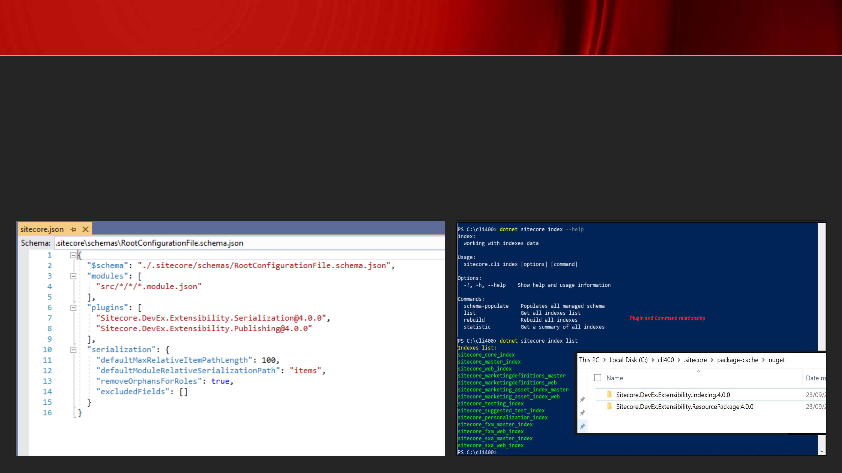Sitecore CLI – sitecore.json

* **Specifies what CLI plugins were installed**
* **If plugins are not installed, commands would not be available**
* **The modules section specifies location of json files having serialization information**
* **If the module.json path is not specified here, serialization will not happen**

Sitecore CLI – module.json

* **The module.json should be added to all folders where serialization must take place**
* **The module.json has item includes that specifies what path must be serialized from the Sitecore tree**
* **If no module.json is present in a folder or content tree path is not specified in module.json the concerned path is not serialized**
* **Dotnet sitecore ser pull used to serialize items to file system**
* **Dotnet sitecore ser push used to deserialize items from file system to Sitecore**

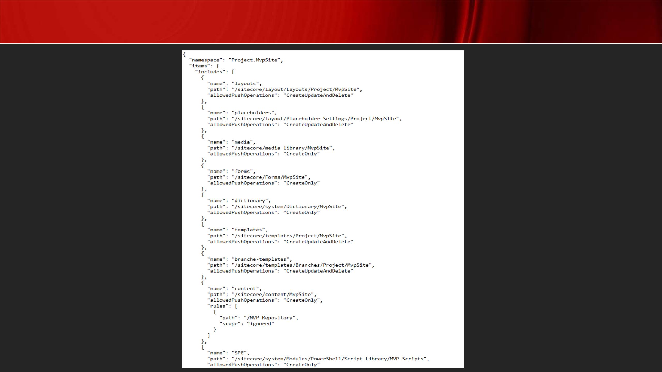Sitecore CLI – module.json

**Structure:**

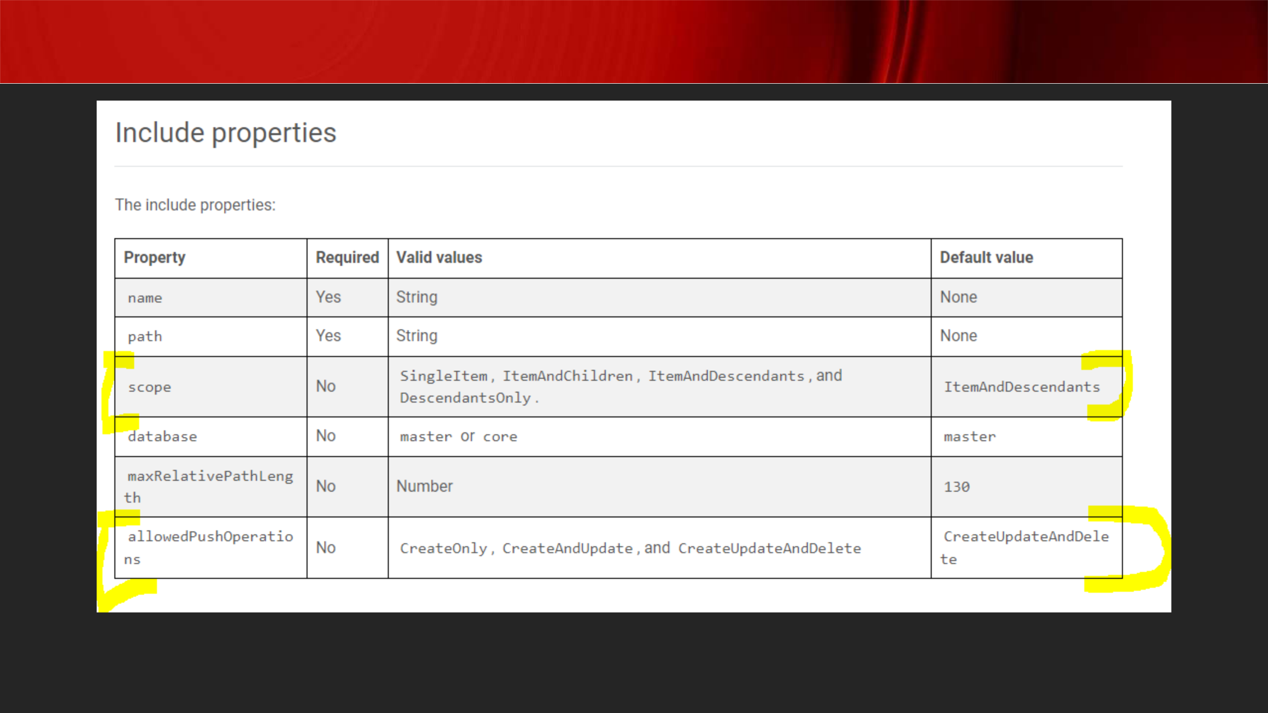

Sitecore CLI – module.json

[**https://doc.sitecore.com/xp/en/developers/101/developer-tools/sitecore-content-serialization-configuration-reference.html**](https://doc.sitecore.com/xp/en/developers/101/developer-tools/sitecore-content-serialization-configuration-reference.html)

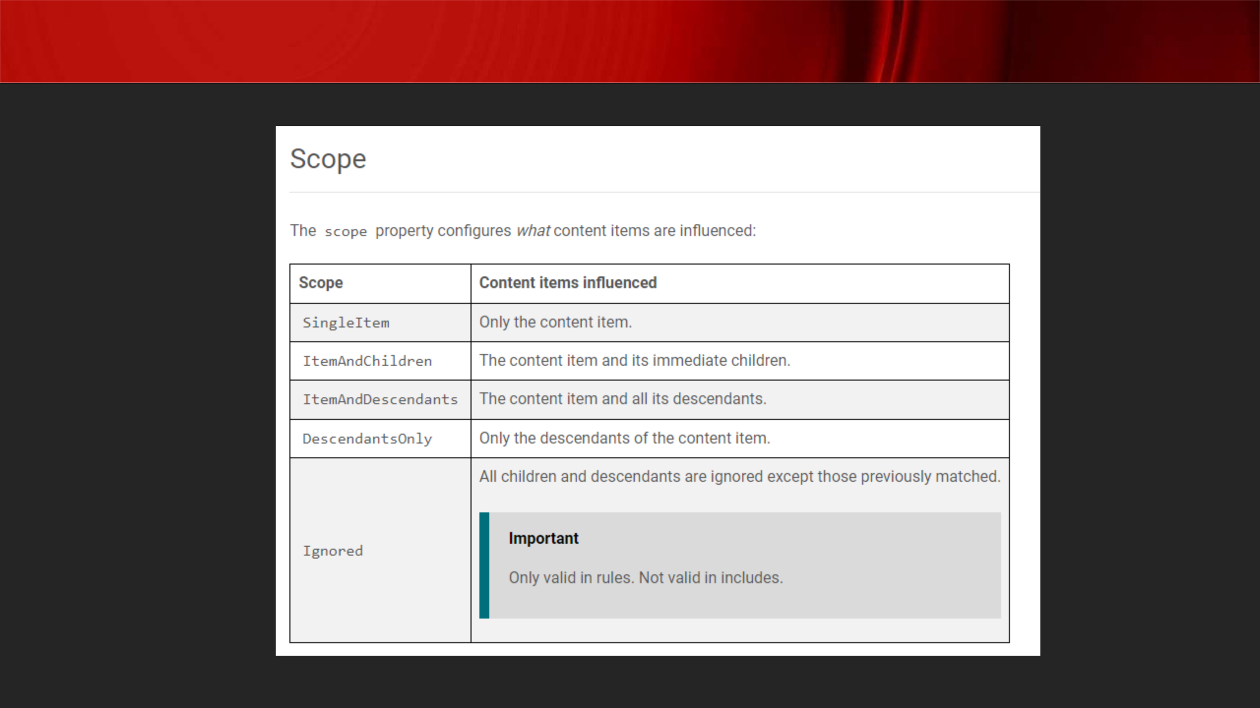Sitecore CLI – module.json

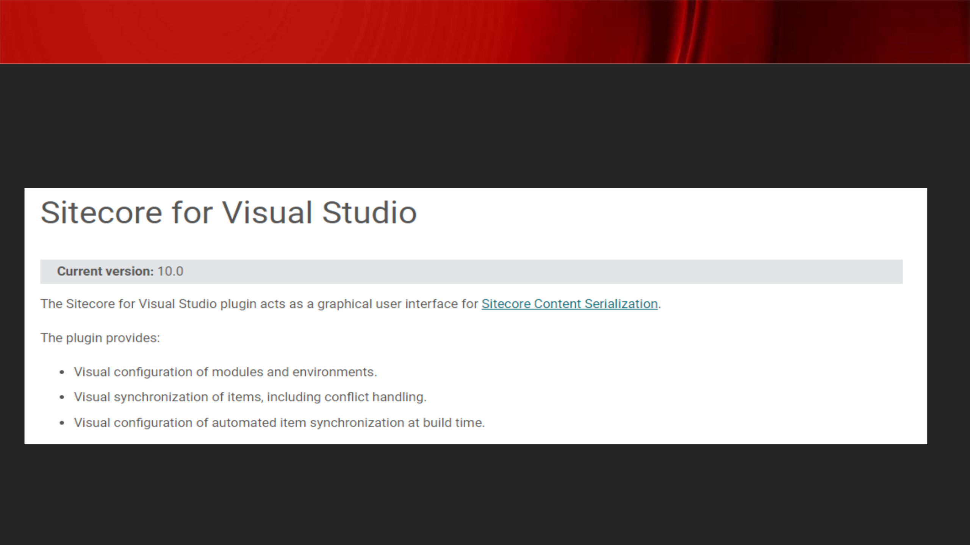Sitecore CLI vs Sitecore for Visual Studio

* **Both tools are created by Sitecore and compatible with one another**
* **Although Sitecore for Visual Studio is licensed**

[**https://doc.sitecore.com/xp/en/developers/100/developer-tools/sitecore-for-visual-studio.html**](https://doc.sitecore.com/xp/en/developers/100/developer-tools/sitecore-for-visual-studio.html)

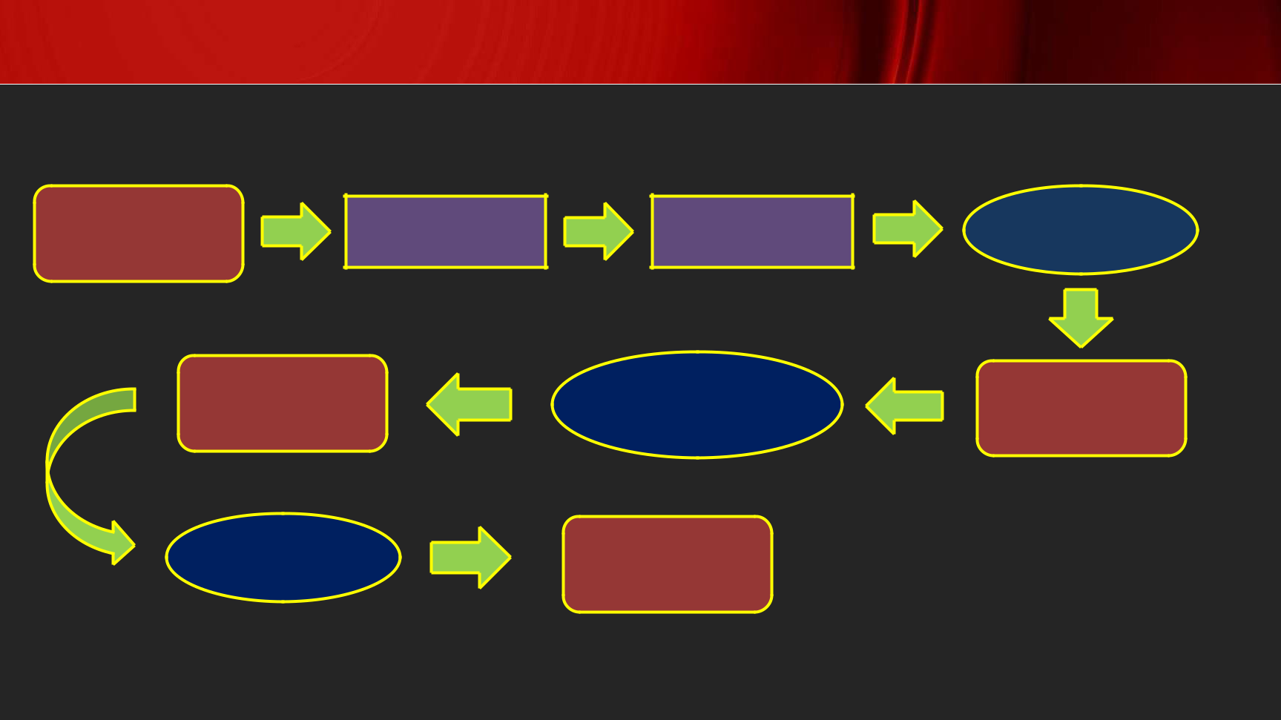Sitecore Docker Lifecycle

* **The below flow describes general lifecycle of Sitecore Docker Container(s)**

Fill Variable

Values

Displays log

Docker-

compose

down

.env file

Docker-

compose.yml

Docker-compose

logs –f <container

name>

Containers

Stopped

Docker-

compose up -d

Containers up and

running

***Tip: From Sitecore 10, Sitecore Container Registry provides base container images for production and development environments***

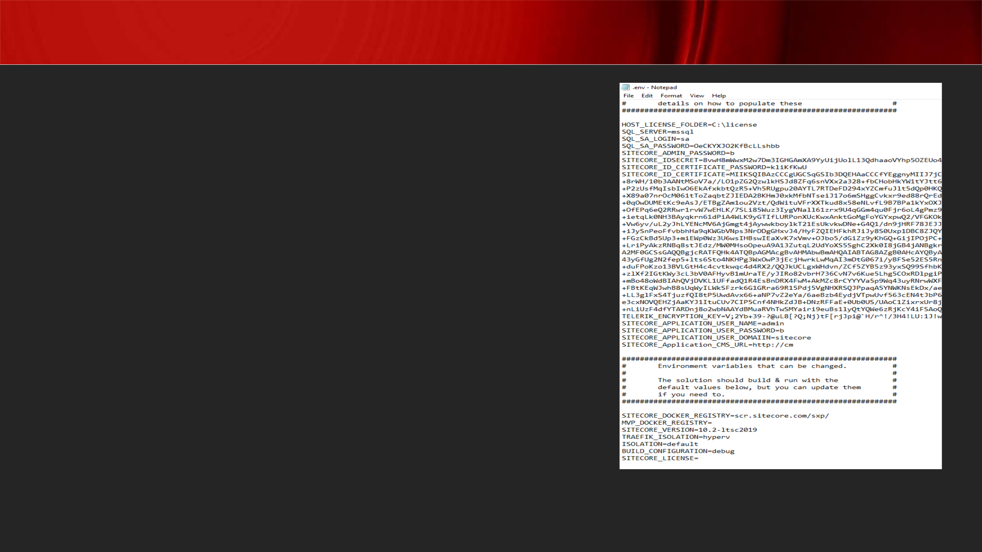.env file

* **The HOST_LICENSE_FOLDER stores the location of license file while SITECORE_LICENSE variable stores the compressed license value**
* **If you receive a conversion error as part of compressing the license file (as below) then use**

**HOST_LICENSE_FOLDER**

Unhandled Exception: System.FormatException: The input is not a valid Base-64 string as it contains a non-base 64 character, more than two padding characters, or an illegal character among the padding characters. at System.Convert.FromBase64CharPtr(Char* inputPtr, Int32 inputLength) at System.Convert.FromBase64String(String s)

[**https://sitecore.stackexchange.com/questions/25991/identity-server-container-fails-to-launch-due-to-license-error-using-headless-ge**](https://sitecore.stackexchange.com/questions/25991/identity-server-container-fails-to-launch-due-to-license-error-using-headless-ge)

Questions & Answers

- NAVAN